



**SM6P07NI Digital Media Project**

**50% Project**

**2023-24 Autumn**

**Student Name:** Kapil Adhikari

**London Met ID:** 22068805

**College ID:** NP01MM4A22014

**External Supervisor:** Shruti Shrestha

**Internal Supervisor: Samir** Maharjan

**Assignment Due Date:** Wednesday, May7, 2025

**Assignment Submission Date:** Wednesday, May7, 2025

**Word Count: 7235**

I confirm that I understand my coursework needs to be submitted online via Google Classroom under the relevant module page before the deadline in order for my assignment to be accepted and marked. I am fully aware that late submissions will be treated as non-submission and a mark of zero will be awarded.

**Project File Links:**

|  |  |
| --- | --- |
| **YouTube Link:** | Keep Unlisted YouTube URL of your Project Here |
| **One Drive Link:** | Keep Google Drive URL of your Project Here with Anyone in Organization can View Option Enabled |

**Abstract**

This document describes the complete process of an advertisement of Dulla\'s leather product. It includes everything from planning (pre-production) to filming the video (production) to editing and finishing it (post-production). This was just a college digital media assignment.

The team began by brainstorming, writing a script and selecting a location. The advertisement was then shot, sound was recorded, and the video was edited to produce the final cut. A meeting with the team at Dullah helped us understand the brand and what they were looking to come across in the ad. Their contribution helped shape the video’s style and message in a big way.

Each step of the project is well-documented with examples and pictures of how it was accomplished. Once the ad was finished, we took it to people and got their feedback. The feedback helped us improve the final video to make it more polished and professional, making sure it matched dulla brand image.

KapilAdikari_22068805.Project.docx

 Islington College,Nepal

Document Details

Submission ID trn:oid:::3618:94675667

80 Pages

8,092 Words

43,045 Characters

Submission Date

May 7, 2025, 9:51 AM GMT+5:45

Download Date

May 7, 2025, 9:53 AM GMT+5:45

File Name KapilAdikari_22068805.Project.docx

File Size

51.4 KB

9% Overall Similarity

The combined total of all matches, including overlapping sources, for each database.

Match Groups

 26 Not Cited or Quoted 7%

Matches with neither in-text citation nor quotation marks

0 Missing Quotations 0%



Matches that are still very similar to source material

 17 Missing Citation 2%

Matches that have quotation marks, but no in-text citation

0 Cited and Quoted 0%



Matches with in-text citation present, but no quotation marks

Top Sources

|  |  |
| --- | --- |
| 2% | Internet sources |
| 0% | Publications |
| 9% | A grey circle on a black background  Description automatically generated Submitted works (Student Papers) |

Integrity Flags

0 Integrity Flags for Review

Our system's algorithms look deeply at a document for any inconsistencies that would set it apart from a normal submission. If we notice something strange, we flag it for you to review.

A Flag is not necessarily an indicator of a problem. However, we'd recommend you focus your attention there for further review.

Match Groups

 26 Not Cited or Quoted 7%

Matches with neither in-text citation nor quotation marks

0 Missing Quotations 0%



Matches that are still very similar to source material

 17 Missing Citation 2%

Matches that have quotation marks, but no in-text citation

0 Cited and Quoted 0%



Matches with in-text citation present, but no quotation marks

Top Sources

|  |  |
| --- | --- |
| 2% | Internet sources |
| 0% | Publications |
| 9% | A grey circle on a black background  Description automatically generated Submitted works (Student Papers) |

Top Sources

The sources with the highest number of matches within the submission. Overlapping sources will not be displayed.

1

Submitted works

University of Wolverhampton on 2021-05-07 2%

2

Submitted works

fpptijateng on 2022-08-04 <1%

3

Submitted works

University of Suffolk on 2021-05-21 <1%

4

Submitted works

islingtoncollege on 2025-03-07 <1%

5

Submitted works

Curtin University of Technology on 2018-05-06 <1%

6

Submitted works

University of Wales Swansea on 2024-03-16 <1%

7

Submitted works

Santa Sabina College on 2025-04-06 <1%

8

Submitted works

Bahrain Polytechnic on 2021-10-23 <1%

9

Submitted works

JMC Academy on 2024-05-05 <1%

10

Submitted works

st-maryshigh on 2022-12-09 <1%

11

Internet

[www.oyasin.io](https://www.oyasin.io/exploring-the-power-of-three-an-in-depth-look-at-the-3-lighting-method-for-photography-and-cinematography/) <1%

12

Submitted works

Walsall College on 2025-03-02 <1%

13

Submitted works

The University of Wolverhampton on 2024-02-18 <1%

14

Submitted works

Edkey - Sequoia Choice Arizona Distance Learning School on 2025-04-24 <1%

15

Submitted works

University of Reading on 2022-05-12 <1%

16

Submitted works

De Montfort University on 2024-05-03 <1%

17

Submitted works

St Leonard's College on 2024-09-04 <1%

18

Internet

[fixit-act.cmtc.ac.th](http://fixit-act.cmtc.ac.th/imagesgall/view/kuz4b40s/archive.php?id=blackmagic-design-tutorials) <1%

19

Submitted works

Asia Pacific University College of Technology and Innovation (UCTI) on 2024-05-29 <1%

20

Submitted works

University of Sussex on 2021-11-18 <1%

21

Submitted works

University of Witwatersrand on 2025-03-26 <1%

22

Internet

[hannahcwmediaproduction.wordpress.com](https://hannahcwmediaproduction.wordpress.com/category/final-major-project/) <1%

23

Internet

[teachinginadigitalworld201.wordpress.com](https://teachinginadigitalworld201.wordpress.com/blog/) <1%

24

Internet

[www.coursehero.com](https://www.coursehero.com/file/221079711/22067520-Dikshya-Sharma-LB-3pdf/) <1%

25

Internet

[www.ukessays.com](https://www.ukessays.com/dissertation/full-dissertations/wes-anderson-films-narration.php?vref) <1%

26

Submitted works

The University of Wolverhampton on 2023-05-18 <1%

27

Submitted works

University of Bedfordshire on 2024-09-07 <1%

28

Submitted works

islingtoncollege on 2025-01-23 <1%

29

Submitted works

Nottingham Trent University on 2023-04-17 <1%

30

Submitted works

The Robert Gordon University on 2022-09-17 <1%

31

Submitted works

University of Northumbria at Newcastle on 2020-04-20 <1%

Contents

Introduction 2

Module Introduction 2

Project Introduction 3

Initial Research 3

Essentials of Commercial Advertising 4

Brand Identity and Product Representation 4

Techniques for Cinematic Product Advertisement 5

Aims of Project 8

Target Audience 8

Software used 9

Software 9

Davinci 9

After effect 11

Technology Employed 11

Lighting Techniques 12

Editing Techniques 13

Mood Boards 14

Resources Planning 15

Schedule 15

Gantt chart 15

Production phase 18

Pre-production phase 18

Concept Research 18

Script 19

Storyboard 23

Cast Selection 54

Location Scouting 54

Mood Board 58

Wardrobe References 67

Cast Selection 67

Production 68

Call sheet 69

Shooting 69

Postproduction Phase 80

Davinci Editing Process 80

Colour Grading 83

Final Rendering 87

Problems and problem solving 88

Cancellation of shoot 88

Execute the design of music in reason. 88

Resources 89

Gears 89

Production Gears 89

Postproduction gears 90

Software 90

Human Resources 90

Testing and Findings 90

Testing 90

Feedback 96

Third Party Evaluation 96

Friend 1 96

Conclusion 100

Appendix 101

**Table of Figure**

Figure 1 Research on importance of commercial. 8

Figure 2 Research on brand identity. 9

Figure 3 Research on technique for wine commercial. 10

Figure 4 Research on cinematic lighting and colouring. 10

Figure 5 Picture showing DaVinci software. 14

Figure 6 picture showing after effect. 15

Figure 7 Used of lighting technique 16

Figure 8 Reference picture showing mood board. 18

Figure 9 Picture showing Gantt chart. 20

Figure 10 Concept Research image. 22

Figure 11 Scene 1 27

Figure 12 Scene 2 28

Figure 13 Scene 3 29

Figure 14 Scene 4 30

Figure 15 Scene 5 31

Figure 16 Scene 6 32

Figure 17 Scene 7 33

Figure 18 Scene 8 34

Figure 19 Scene 9 35

Figure 20 Scene 10 36

Figure 21 Scene 11 37

Figure 22 Scene 12 38

Figure 23 Scene 13 39

Figure 24 Scene 14 40

Figure 25 Scene 15 41

Figure 26 Scene 16 42

Figure 27 Scene 17 43

Figure 28 Scene 18 44

Figure 29 Scene 21 48

Figure 30 Scene 22 49

Figure 31 Scene 23 50

Figure 32 Scene 24 52

Figure 33 Scene 25 53

Figure 34 Scene 26 54

Figure 35 Scene 27 55

Figure 36 Scene 28 56

Figure 37 Scene 29 57

Figure 38 Image of location Taaj palace. 59

Figure 39 Image of location indoor 1. 60

Figure 40 Image of location indoor 2. 61

Figure 41 Image of location indoor 3. 61

Figure 42 Image of location indoor 4. 62

Figure 43 Creating Reference Mood Board 1 63

Figure 44 Creating Reference Mood Board 2 64

Figure 45 Creating Reference Mood Board 3 65

Figure 46 Creating Reference Mood Board 4 66

Figure 47 Creating Reference Mood Board 5 67

Figure 48 Creating Reference Mood Board 6 68

Figure 49 Creating Reference Mood Board 7 69

Figure 50 Creating Reference Mood Board 8 70

Figure 51 Image of Shooting 1 74

Figure 52 Image of Shooting 2 75

Figure 53 Image of BTS 1 77

Figure 54 Image of BTS 2 78

Figure 55 Image of BTS 3 79

Figure 56 Image of BTS 4 80

Figure 57 Image of BTS 5 81

Figure 58 Image of BTS 6 82

Figure 59 Image of BTS 7 83

Figure 60 Reference music for dulla commercial 93

Figure 61 Image showing Testing 95

Figure 62 Image of Survey 2 96

Figure 63 Image of Survey 3 97

Figure 64 Image of Survey 5 98

Figure 65 Image of Survey 6 99

Figure 66 People Giving Feedback on video 100

Figure 67 Image of logsheet1 105

Figure 68 Image of log sheet 2 106

Figure 69 Image of log sheet 3 107

Figure 70 Image of log sheet 4 108

Figure 71 Image of log sheet 5 109

Figure 72 Image of log sheet 7 110

Figure 73 Image of log sheet 7 111

Figure 74 Image of log sheet 8 112

Figure 75 Image of log sheet 9 113

Figure 76 Image of log sheet 10 114

Figure 77 Image of log sheet 11 115

Figure 78 Image of log sheet 12 116

Figure 79 Image of log sheet 13 117

Figure 80 Image of log sheet 14 118

Figure 81 Image of log sheet 15 119

Figure 82 Image of log sheet 16 120

Figure 83 Managing Project in Trello 1 121

Figure 84 Managing Project in Trello 2 121

Figure 85 Managing Project in Trello 3 122

Figure 86 Managing Project in Trello 4 122

.

# Introduction

## Module Introduction

The aim of the project was to create a strong commercial advertising of Dulla; a Nepali premium leather brands. The team started with intense desk research and brainstorming to deliver a concept that connects with the brand’s attitude and target customers. This was followed by the production of an innovative media project using best industry-standard practice and techniques, including preproduction, shooting and postproduction.

Supervisors, the client, and practitioners in the domain of advertising were consulted on numerous occasions throughout the project. This feedback was essential in the advertisement being honed to such a high, professional standard.

A formalized feedback loop ensured that everything was constantly refined at every step in the production process. The exercise developed more than just technical skills, however, with collaboration, time management and creative development all allowed to grow too. I mean we all played huge parts in it too, we all did, you know, and it was a gratifying as well as personally satisfying project."

## Project Introduction

The main goal of this digital media project was to create a professional and visually appealing commercial for Dulla, a well-known Nepali leather brand. The advertisement focused on showcasing Dulla’s products leather bags, shoes, boots, and wallets through a modern and stylish approach suitable for social media platforms.

The production team carefully followed the client’s preferences throughout the process. The project began with research and team brainstorming to generate creative ideas. Industry-standard software like Davinci and Adobe After Effects was used for editing, animation, visual design, and rendering. Each step was done with care to maintain high quality and professionalism.

To improve the final output, feedback will be collected using Google Forms and email. Suggestions will be gathered from supervisors, the client, and people experienced in filmmaking and video editing. This feedback will be used to make any necessary changes and ensure the final product meets professional standards.

This project also served as a learning opportunity for the team. It helped them develop practical skills like time management, creative thinking, teamwork, and client communication. Along with technical experience, the team also gained personal growth, making the project both valuable and rewarding.

## Initial Research

Research and Planning for the Dulla leather product commercial Proper research and planning is important when you want to create something. The team reviewed the brand’s personality, customer preferences and trends in the current market to identify the best method of promoting Dulla’s leather bags, shoes, boots, and wallets. Objective was to produce a commercial that not only connects with audience but also portrays premium imagery of Dulla.

That led to a lot of pre-production planning to make sure everything went smoothly on set. Strong creative vision and clear roadmap was established to lead the production. In those hundreds of hours, the team aimed to create more than just another commercial that met the client’s expectations to deliver one that wowed viewers, not just on presence, but also in look and story.

### Essentials of Commercial Advertising

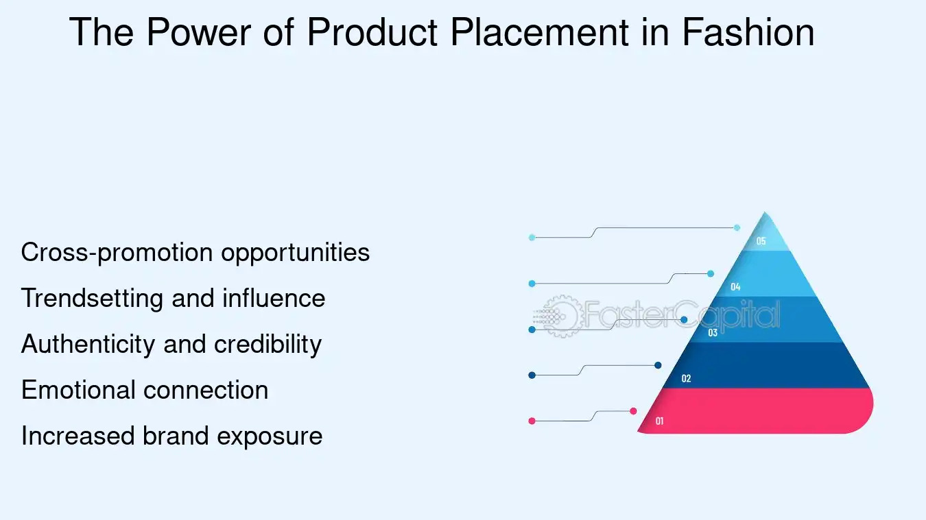

Figure Research on importance of commercial.

To effectively produce a commercial advertisement, the basics of advertising must be in place. For the Dulla project, I started searching and studying about how big brands portray their products, not only from a visual perspective, but also an emotional one. Elements such as product placement, emotional triggers & call-to-action messaging were analyzed to help create a successful and engaging ad. By analyzing successful leather product advertisements case studies, the team learned how a brand such as Dulla could differentiate itself from competitors by emphasizing craftsmanship, quality, and lifestyle. Now that these fundamentals were cemented, the other pieces really fell into place with the remainder of the production and voice direction serving as a general tone and structure toward the final ad.

### Brand Identity and Product Representation

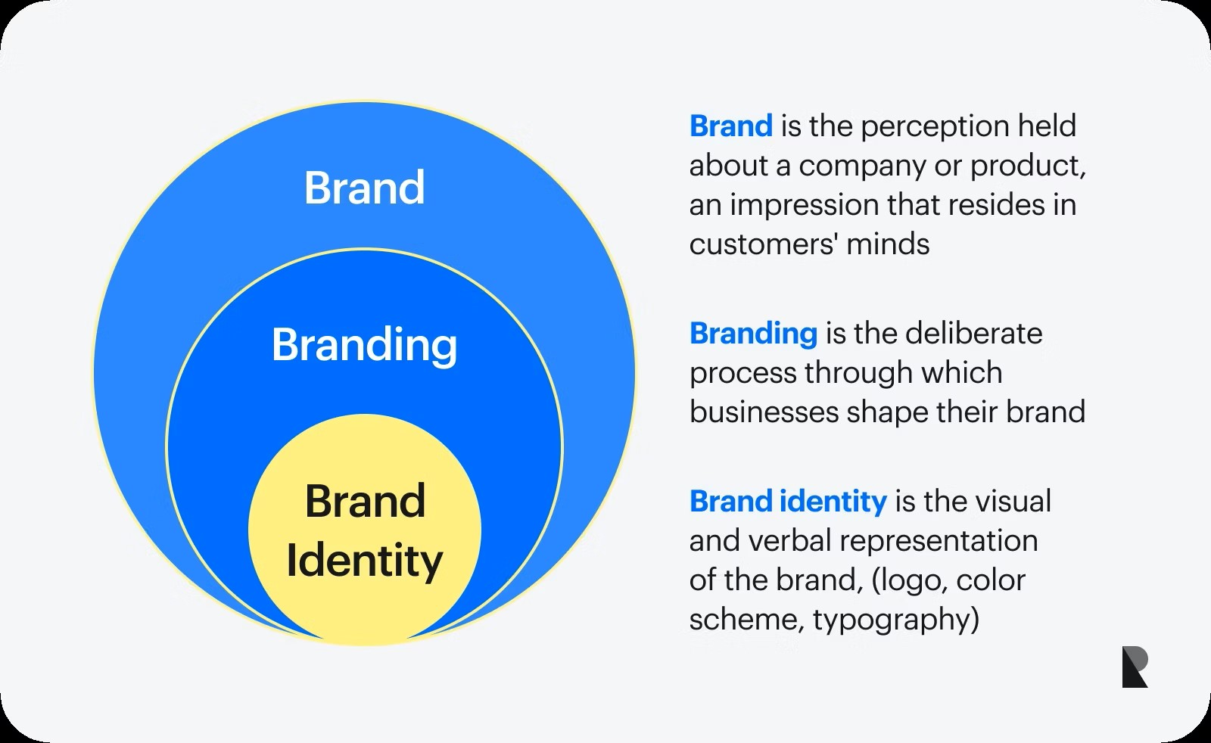

(Ramotion, Aug 25,2023)

Figure Research on brand identity.

A vital aspect of creating an authentic commercial is staying true to the brand’s core identity. In this project, research was conducted to understand Dulla's unique positioning as a Nepali brand that emphasizes handmade leather craftsmanship, and style. The team examined visual storytelling techniques that convey brand values without being overly promotional. This included colour choices, mood, camera angles, and subject framing that reflect Dulla's elegance and premium nature. The advertisement aimed to create an emotional connection with the audience by showcasing the making of the product and the lifestyle of its users. This strategy not only promoted the product but also reinforced brand loyalty and trust.

### Techniques for Cinematic Product Advertisement

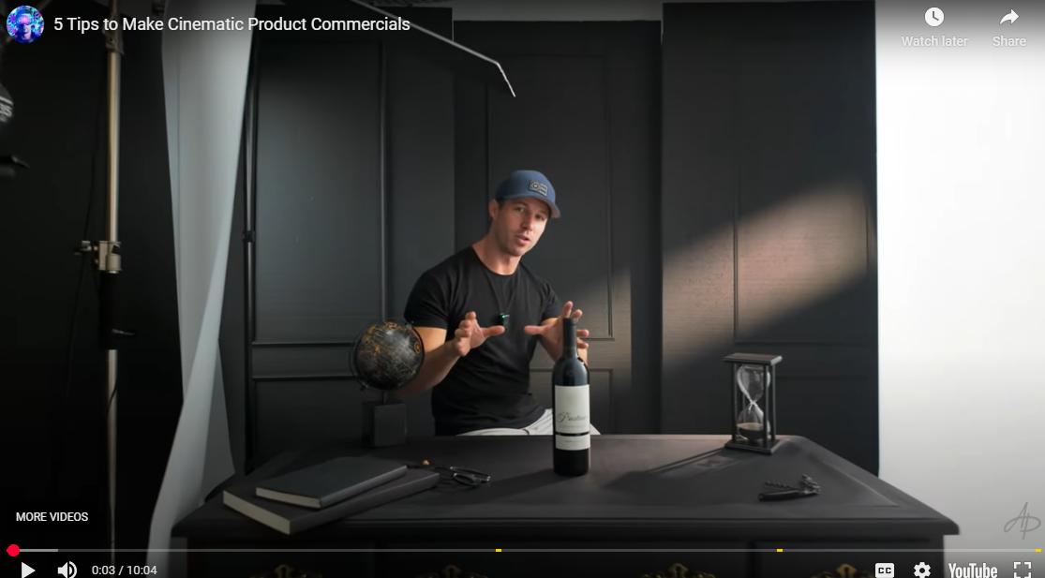

(paul, Sep 18, 2024)

Figure Research on technique for wine commercial.

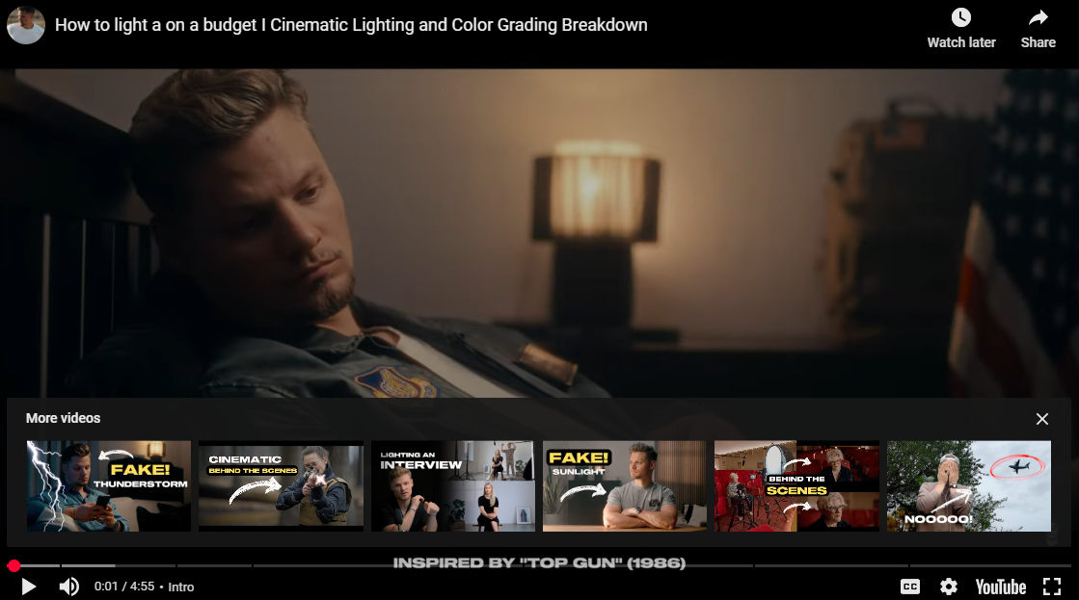

(TWIZE, Apr 16, 2025)

Figure Research on cinematic lighting and colouring.

To produce a sleek and high quality commercial, progressive production techniques from the film industry were used in product-based advertising. The lighting design was selected to emphasize leather texture and quality and both slow motions, controlled depth of field and a cohesive color grading system was utilized to add to the visual lushness of Dulla’s products. All the frames were finalized in Adobe Premiere Pro and DaVinci Resolve with professional toolkit to make it looks with a slick and unique visual.

Background music was instrumental to defining atmosphere and reinforcing the brand. Appropriate, royalty-free music was found on services like Epidemic Sound and Artist to accompany the imagery. By combining the elements of strong visual and sound, as well as narrative flow, we made the last commercial greatly impressing and gave the audience a lasting impression.

# Aims of Project

The Dulla commercial project aims to stand out by focusing on visual presentation, character styling, and brand appeal. Through creative planning and execution, it seeks to establish a unique identity in the fashion and lifestyle advertising space. By highlighting elegance, confidence, and product quality, the project aims to make a lasting impression and strengthen customer connection with the brand.  
The project’s final product will be used for the purposes listed below:

• Promote Dulla’s leather products including bags, shoes, and wallets to a wider fashion-forward audience.  
• Bridge the gap between local craftsmanship and modern consumer expectations through visually engaging content.  
• Encourage appreciation for Nepali-made products by showcasing style, quality, and character through cinematic visuals.

# Target Audience

**Age Group:**

Dulla is primarily targeted at anyone aged from 22 to 40 years old; young professionals, budding entrepreneurs, and older years students. At this point in life personal style and career attire are of increasing significance for these individuals.

**Gender**:

The ad aims indirectly at not being gender biased featuring Dulla's leather goods like bags, shoes and wallets that are used by men or women. This styling exudes class and confidence, making it accessible to numerous customers of any gender identity.

**Socio-Economic Status & Profession:**

It is aimed at people earning a middle to upper-middle income who are open to spend on premium lifestyle products. These can be people in corporate roles, people in creative industries such as design, media and technology, and business owners, who seek quality, utility, and aesthetic appeal in their clothing.

**Hobbies & Lifestyle:**

This demographic is likely to appreciate style, purpose, and sustainability. As for their interests, they may include travel, the coffee culture, social events, and the fashion expertise that is shared over digital platforms. These buyers care about style but want function, often opting for something beautiful but built to last. This discerning group not only appreciates local craftsmanship but is also more open to homegrown brands who can retain global qualities.

**Location & Market Approach:**

The campaign target’s urban locations of Nepal: Kathmandu, Pokhara and Lalitpur where the target demographic group is most densely populated. This word is a digital marketing strategy where Instagram, TikTok, and Facebook are the virtual streets of the city to increase its visibility, a place not only for the locals but also for the locals who have gone overseas, and they are part of the diaspora who still want the true and authentic leather goods made from Nepal.

# Software used

## Software

Software is a set of instructions or programs that tell a computer what to do. It helps devices perform specific tasks and functions. Unlike hardware, which includes the physical parts of a computer (like the keyboard, mouse, or monitor), software is the digital part that runs inside the system.

Software includes things like applications, games, scripts, and programs that users interact with. These programs make it possible for the device to work smoothly and conduct different activities such as editing videos, browsing the internet, or designing graphics. Without software, hardware alone would not be able to function properly.

## Davinci

DaVinci Resolve is at the heart of the vast majority of post-production facilities and is a unique and also vast software that spans from the camera to the crayons (too much of a pun on the logo?). It combines different processes editing, color correction, visual effects, motion graphics and audio post-production in one software. This integration is extremely powerful because it saves users from having to change between software tools, which normally is very time-consuming.

Easy to use One of the main advantages of DaVinci Resolve is that this is a modern and user-friendly software that has an interface that you can quickly understand if you are a beginner with the option to show advanced features for professional users. This makes it perfect for beginners as well as professionals.

The software allows users to keep camera footage in original condition all the way through the post process’ no matter how many generations down the workflow ‘drastically reducing the loss in quality sometime associated with the color grading process. This is especially important when more professional grade work needs to be done on the content, maintaining quality control along the way. (logo, n.d.)



Figure Picture showing DaVinci software.

## After effect



Figure picture showing after effect.

Adobe After Effects is a powerful 2.5D animation software widely used in the creation of animations, visual effects, and motion picture compositing. It is primarily used during the post-production phase of video production, and its versatility makes it a go-to tool in industries such as film, television, and web video creation.

The software provides a vast range of effects that allow users to manipulate images and videos with precision. After Effects enables the combination of multiple layers of video and images within a single scene, providing the flexibility to create complex visual compositions. This ability to integrate various visual elements is one of the key strengths of After Effects.

# Technology Employed

## Lighting Techniques

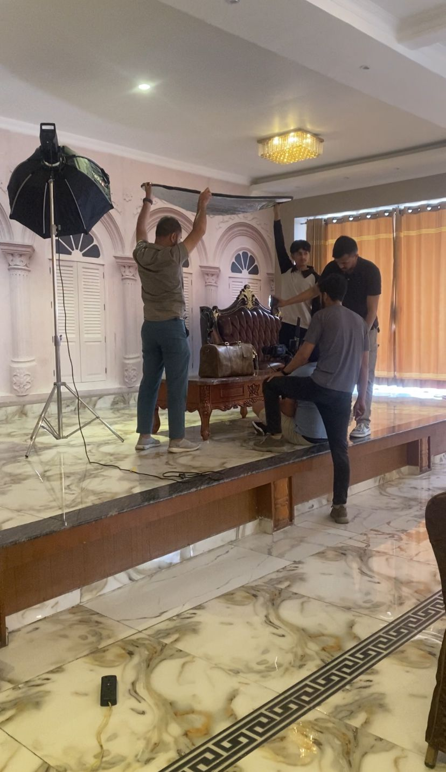

Figure Used of lighting technique

**Key Light**

The key light was the main source of light, setting the exposure and mood of every scene. The light was angled perfectly to demonstrate the model and the Dulla products, but kept its punchiness nice and soft in those regions. This technique is basic to cinematic lighting, providing shape and emphasis in the frame.

**Fill Light**

A fill light was used to soften shadows created by the key and balance contrast, especially near the subject's face and areas around him as it was complementary to the key light. This method created a pleasing image that had soft shadow areas and dark regions of the frame that had retained detail.

**Tube Light**

In the case of product specific shots, especially the Dulla leather bag, tube lights were incorporated to give reflections on the products to highlight the texture and craftsmanship. Lighting in this way boosts its aesthetics and gives prominence to the quality of leather material.

## Editing Techniques

**Standard Cuts**

This editing method uses traditional cuts to organize clips into a logical, rhythmic sequence, creating harmony with the flow of the story and beats of the music. The technique guaranteed that each cut from one scene to the next would be smooth, and keep the audience engaged and the narrative flowing.

**Speed Ramping**

I further employed speed ramping to make the whole sequence more dynamic, and to highlight certain actions. They tease a clip that is altered so that it speeds up slowly then normally plays but then slows down just as slowly to another speed and speed so on and off. It was cleverly utilized to underscore the walking and movements of the model or even her sheering the Dulla products, giving the ad a cinematic profile.

## Mood Boards

A mood board is a visual presentation used to express the overall style, tone, and concept of a project. It is usually made by collecting images, colors, text, patterns, or materials that represent the desired look and feel. These elements are arranged in a way that helps guide the creative process.

Mood boards can be physical (made with paper and cutouts) or digital (created using software). They are often used in design, film, fashion, and advertising to communicate ideas clearly to a team or client. By using a mood board, creators can stay focused on the project's theme and make sure all visual elements match the intended mood. It also helps everyone involved in the project understand and follow the same creative direction. (Wikipedia, n.d.)

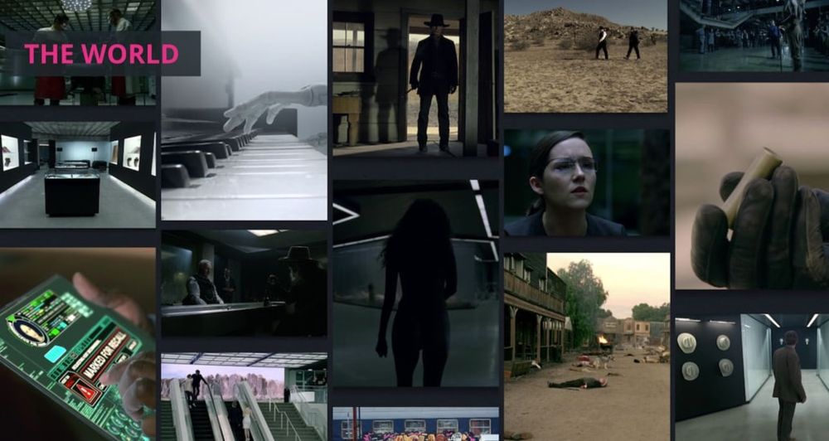

(everpost, n.d.)

Figure Reference picture showing mood board.

# Resources Planning

.

**Budgeting**

Alongside these activities, the project's budget planning was conducted. A detailed cost estimate was prepared, taking into account cast fees, location charges, equipment rentals, transportation, and miscellaneous production expenses. This budgeting phase ensured that all elements of the shoot could be executed efficiently without compromising on quality, while staying within the financial constraints of the project.

|  |  |  |
| --- | --- | --- |
| **S. N** | **Items** | **Price** |
| 1 | Director | Rs 5000 |
| 2 | Cinematographer | Rs 15000 |
| 3 | Assistant director& cinematographer | Rs 5000& Rs 5000 |
| 4 | Casts (1 model) | Rs 7000 |
| 5 | Camera and lenses (included in package) | Rs 10000 |
| 6 | Gimbal and Tripod | Rs 3000 |
| 7 | Lighting | Rs 4000 |
| 8 | Digital Screen for Camera | Rs 1500 |
| 9 | Transmitter | Rs 1500 |
| 10 | Food Expenses | Rs 7000 |

# Schedule

## Gantt chart

A Gantt chart was made to represent the entire project timeline from then to the end. It featured everything from research, idea planning, filming, editing, and final work. The chart kept the team organized in meeting all of the tasks on time. It was also a simple way to see what needed to be done next and for everyone to keep tabs on the work.

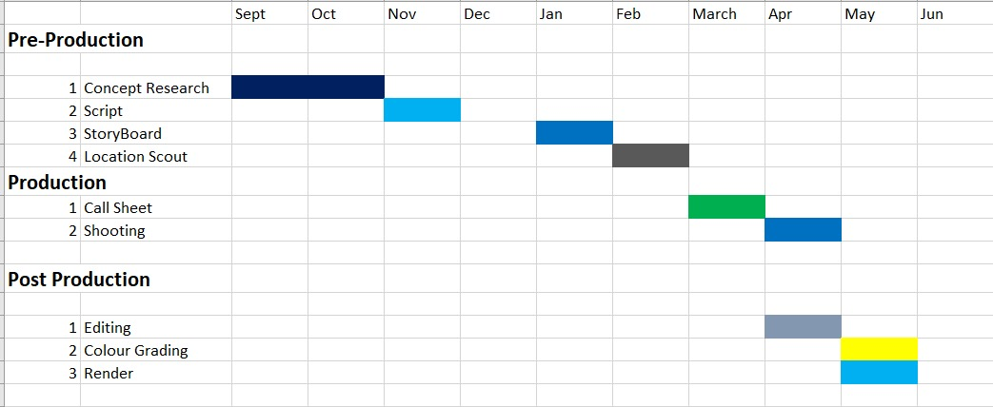

Figure Picture showing Gantt chart.

**Pre-Production Schedule**

**September – February**

The Pre-Production of the Dulla advertisement started in September, starting with Concept Research; That involves it identity of brand, how to use the leather goods into situation of real life, relatable life. Phase 1 Phase 1 was finalized during October after names, brand values, and creative ideas were gathered.

Storyboard and Script went through the month of December and on into January. The script was rewritten numerous times to improve the tone, message, and plot. At the same time, storyboards were drawn up to sketch each scene vividly, with fleshed-out frames directing how they would be shot, when the camera would pan up or down, how Dulla’s shoes, bags and wallets will be shot in diverse scenes.

The visual plan and final adjustments to the storyboard were completed in February. This stage made certain that all was ready for the shoot.

**Production Schedule  
January – March**

The Call Sheet was prepared in January to coordinate logistics for the shoot, such as securing locations and crew, as well as equipment requirements. Shooting started in February and was extended through March, in curated environments such as cafés and office spaces that demonstrated the versatility of the product.

Every scene was shot highlighting the premium-ness of Dulla through creative set up and lighting. The model moved from dressed up to dressed down, emphasizing the wear-it-anywhere sensibility of the product. Scattered about were two days of reshoots to maintain brand consistency and visual quality.

**Post-Production Schedule  
April – May**

Post-production started in April with Media Organization – all the footage was logged and looked at. The first cut edit, followed the story board and brand tone, was put together in DaVinci Resolve. Editing emphasized rhythm, absence of jarring transitions, and pacing that suited Dulla’s contemporary, sophisticated character.

In the middle of April, the Review and the Color Grading was made. Color correction was "done according to a mood board, so that the leather looks extra good, and the colors will match up from scene to scene".

The project reached its closing stages with Render in May. The final audio mix was done with jazz-inspired instrumentals as well as ambient sfx to augment the emotional premium feel of the spot. Project documentation and post-production work were concluded by May, where details of the creative process were revealed along with how it aligned with the values of Dulla.

# Production phase

## Pre-production phase

### Concept Research

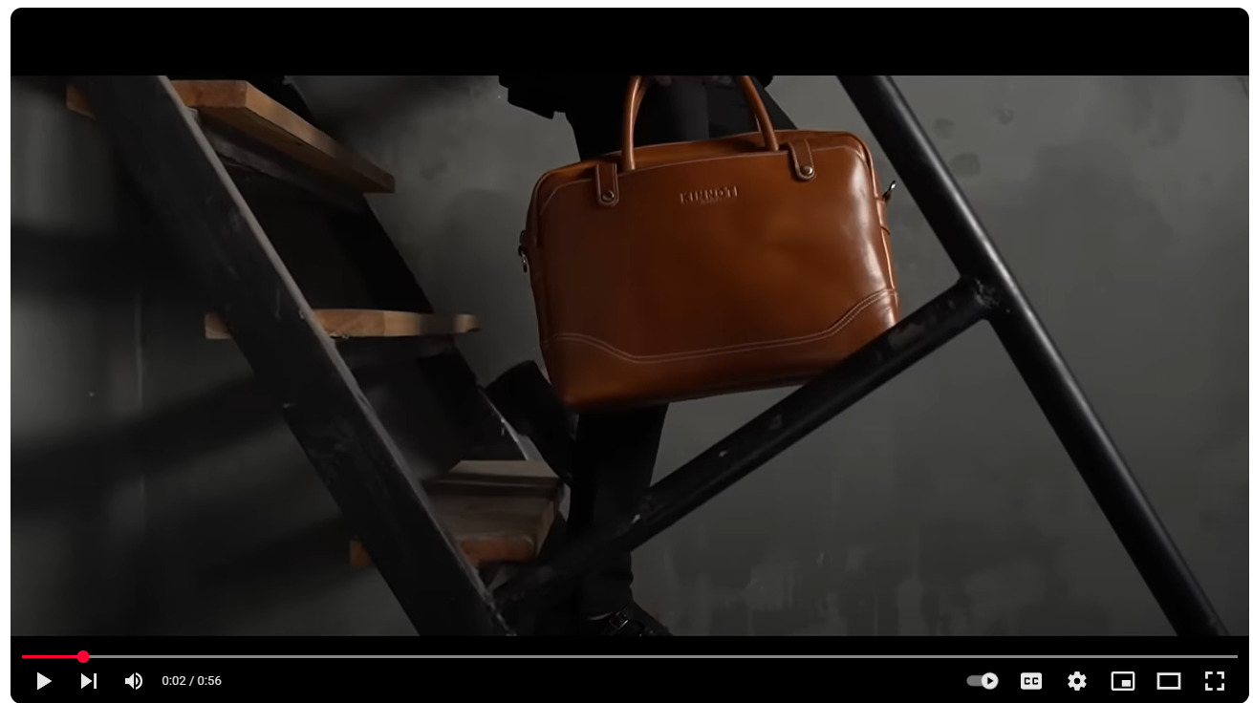

(kinnoti, n.d.)

Figure Concept Research image.

The inspiration for the Dulla leather commercial is from high fashion commercials of the 21st century like the Kinnoti Leather bag commercial. Like Kinnoti, this project emphasizes clean and minimalistic visuals with an emphasis on the quality, craftsmanship, and aesthetic of leather goods. Controlled lighting and smooth camera movements, the briemayers pointed out, along with artful closeups of the product presentation had a big impact on the look of this project.

Instead of 'saying,' Dulla commercial focuses on 'showing' non-verbal storytelling, letting the model's own body language, dress-up, and environment speak for themselves sophistication, practicality, and lifestyle. Motivation following the sophisticated cinematic look and feel encouraged by brands similar to Kinnoti, this project seeks to elevate Dulla not as a leather goods brand, but as a statement of sophisticated style along with personality.

### Script

**DULLA ADVERTISEMENT SCRIPT**

**SCENE 1**

**INT. STUDIO – DAY**

On-screen animation of the Dulla logo for brand identity.

**SCENE 2**

**INT. STAIRCASE – DAY**

A model steps down a ladder, carrying a Dulla side bag. The bag moves and the design of the bag comes into the camera. Camera follows bag capturing it.

**SCENE 3**

**INT. STAIRCASE – DAY**

The camera follows the model as he descends the stairs. Then we see a camera go from a shot (long shot) to a shot (medium shot) from the front, showing the model and the Dulla bag.

**SCENE 4**

**EXT. OFFICE PARKING LOT – DAY**

A car enters the office premises. Wide shot as the car gets closer.

**SCENE 5**

**EXT. OFFICE PARKING LOT – DAY**

The model exits the car. As the feet of the model touches the ground, a low angle shot captures the Dulla shoes.

**SCENE 6**

**EXT. OFFICE PARKING LOT – DAY**

A Dulla bag is taken out of the car by the model. A medium shot of the model and the car in the background as it drives away.

**SCENE 7**

**INT. OFFICE ENTRANCE – DAY**

The model walks into the office, door opening. All this plays out in a low angle medium shot from the side.

**SCENE 8**

**INT. OFFICE HALLWAY – DAY**

A model strutting in Dulla side bag. From a medium shot that follows the model's stride and demeanor.

**SCENE 9**

**INT. OFFICE – DAY**

The Dulla bag in close-up, showcasing its craftsmanship and details.

**SCENE 10**

**INT. OFFICE – DAY**

Dulla bag on the table, showing its usability. (medium shot of the model)

**SCENE 11**

**INT. OFFICE – DAY**

Detail-oriented: Close-up of the model with the action of adjusting the belt.

**SCENE 12**

**INT. OFFICE – DAY**

A close-up shot over the shoulder as the model opens the Dulla bag that is so deep.

**SCENE 13**

**INT. OFFICE – DAY**

Close-up shot of the model unzipping the bag and the point of the zipper.

**SCENE 14**

**INT. OFFICE – DAY**

Close-up shot focusing on the Dulla logo on the bag, reinforcing brand identity.

**SCENE 15**

**INT. OFFICE – DAY**

Medium shot of the model using a mobile phone, with the dulla bag visible on the table.

**SCENE 16**

**INT. OFFICE – DAY**

A Macro shot showing all the minute details of the Dulla bag; highlighting the premium aspect of the bag.

**SCENE 17**

**INT. STUDIO – DAY**

low angles SHOT, three different Dulla shoes with transition is shown.

**SCENE 18**

**EXT. BUILDING ENTRANCE – DAY**

The model exits the building in a new outfit, carrying a Dulla backpack and wearing casual shoes. Low-angle side shot captures the ensemble.

**SCENE 19**

**EXT. STREET – DAY**

Close shot of the model facing the side, poised to move forward, exuding confidence.

**SCENE 20**

**EXT. STREET – DAY**

Wide shot from a low angle of the model walking towards us in Dulla Backpack and casual shoes. It showcases how the model would pose in a few different ways, highlighting the products.

**SCENE 21**

**EXT. STREET – DAY**

Low angle shot focusing on the Dulla Casual shoes as the model walks forward, highlighting their design and comfort.

**SCENE 22**

INT. COFFEE SHOP – DAY

Wide shot of the model in focus and a coffee shop worker handing over a coffee cup to model, close up of the model's hands getting the cup where bag backpack is shown as secondary focus.

**SCENE 23**

**INT. COFFEE SHOP – DAY**

Medium shot capturing the model enjoying coffee, with the dulla bag and outfit complementing the setting.

**SCENE 24**

**INT. COFFEE SHOP – DAY**

The model takes out an ATM card from Dulla wallet close up shot to show the usage of wallet.

**SCENE 25**

**INT. STAIRCASE – DAY**

Low angle shot focusing on the dulla casual shoes as the model descends the stairs, camera pans from left to right.

**SCENE 26**

**EXT. STREET – DAY**

Wide shot of the model reading dulla magazine

**SCENE 27**

**EXT. STREET – DAY**

Wide shot of the model posing with the dulla magazine, capturing a moment of stillness amidst the bustling background.

**SCENE 28**

**EXT. STREET – DAY**

Medium shot setup of the model holding the Dulla magazine but not moving as people and vehicles pass by in the background.

**SCENE 29**

**INT. STUDIO – DAY**

The Dulla slogan appears on screen, concluding the advertisement with a strong brand message.

### Storyboard

|  |  |  |
| --- | --- | --- |
| **Scene** 1 | **Shot:** Wide shot / Tracking  Shot |  |
| **Location Indoor** |  |  |
|  | | |

Figure Scene 1

**Scene Description:**

Scene Description: A model steps down a ladder, carrying a Dulla side bag. The bag moves and the design of the bag comes into the

|  |  |  |
| --- | --- | --- |
| **Scene** 2 | **Shot: wide shot / Medium shot** |  |
| **Location Outdoor** |  |  |
|  | | |

Figure Scene 2

**Scene Description**: Model coming downstairs as camera captures scene from side to front.

|  |  |  |
| --- | --- | --- |
| **Scene** 3 | **Shot: Wide shot** |  |
| **Location Outdoor** |  |  |
|  | | |

Figure Scene 3

**Scene Description**: Model driving towards parking lot as camera captures from wide.

|  |  |  |
| --- | --- | --- |
| **Scene** 4 | **Shot:** low angle shot |  |
| **Location Indoor** |  |  |
|  | | |

Figure Scene 4

**Scene Description**: Character steps out from the car where camera capture low angle shots capturing shoes.

|  |  |  |
| --- | --- | --- |
| **Scene** 5 | **Shot: Medium shot** |  |
| **Location** Outdoor |  |  |
|  | | |

Figure Scene 5

**Scene Description**: The model takes out dulla bag from the car as camera captures with medium shot.

|  |  |  |
| --- | --- | --- |
| **Scene** 6 | **Shot:** Low angle shot |  |
| **Location Indoor** |  |  |
|  | | |

Figure Scene 6

**Scene Description**: Camera Captures the model entering office from the door.

|  |  |  |
| --- | --- | --- |
| **Scene** 7 | **Shot:** Low angle medium shot | **Duration** 6 seconds |
| **Location Indoor** |  |  |
|  | | |

Figure Scene 7

**Scene Description:** Camera captures model walking walking and holding dulla bag.

|  |  |  |
| --- | --- | --- |
| **Scene** 8 | **Shot:** Close-up shot of dulla bag |  |
| **Location Indoor** |  |  |
|  | | |

Figure Scene 8

Scene Description: Camera captures close up shot of dulla bag.

|  |  |  |
| --- | --- | --- |
| **Scene** 9 | **Shot:** Medium shot |  |
| **Location Indoor** |  |  |
|  | | |

Figure Scene 11

Scene Description: Model places dulla bag on the table.

|  |  |  |
| --- | --- | --- |
| **Scene** 10 | **Shot:** Close-up shot |  |
| **Location Indoor** |  |  |
|  | | |

Figure Scene 10

**Scene Description**: Model adjusting belt and showing attention to detail.

|  |  |  |
| --- | --- | --- |
| **Scene** 11 | **Shot:** Over the shoulder close up |  |
| **Location Indoor** |  |  |
|  | | |

Figure Scene 11

**Scene Description**: Model opens dulla bag and show details of chain.

|  |  |  |
| --- | --- | --- |
| **Scene** 12 | **Shot:** Close up shot | **Duration** 6 seconds |
| **Location Indoor** |  |  |
|  | | |

Figure Scene 12

**Scene Description**: Model unzips bag highlighting quality of zipper.

|  |  |  |
| --- | --- | --- |
| **Scene** 13 | **Shot:** Closeup shot |  |
| **Location Indoor** |  |  |
|  | | |

Figure Scene 13

**Scene Description**: Camera Captures dulla logo on tag holding on zipper.

|  |  |  |
| --- | --- | --- |
| **Scene** 14 | **Shot:** Medium shot |  |
| **Location Indoor** |  |  |
|  | | |

Figure Scene 14

**Scene Description:** Camera captures model using mobile phone while bag remain secondary focused.

|  |  |  |
| --- | --- | --- |
| **Scene** 15 | **Shot:** Close up shot | **Duration** 6 seconds |
| **Location Indoor** |  |  |
|  | | |

Figure Scene 15

**Scene Description:** Camera captures fine details of dulla bag.

|  |  |  |
| --- | --- | --- |
| **Scene** 16 | **Shot:** Low angle shot |  |
| **Location Indoor** |  |  |
|  | | |

Figure Scene 16

**Scene Description**: Camera captures transition sequence showcasing three dulla shoes.

|  |  |  |
| --- | --- | --- |
| **Scene** 17 | **Shot:** Low angle shot |  |
| **Location Indoor** |  |  |
|  | | |

Figure Scene 17

**Scene Description:** Camera captures model coming out from the building carry new bag pack and wearing casual shoes.

|  |  |  |
| --- | --- | --- |
| **Scene** 18 | **Shot:** Medium Shot |  |
| **Location** Outdoor |  |  |
|  | | |

Figure Scene 18

**Scene Description**: Camera captures model giving different poses focusing dulla product.

|  |  |  |
| --- | --- | --- |
| **Scene** 19 | **Shot:** Wide shot from low angle |  |
| **Location** Outdoor |  |  |
|  | | |

Figure Scene 19

**Scene Description**: Camera captures model giving different pose.

|  |  |  |
| --- | --- | --- |
| **Scene** 20 | **Shot:** low angle wide shot |  |
| **Location** Outdoor |  |  |
|  | | |

Figure Scene 20

**Scene Description**: Camera captures dulla casual shoes as he moves forward.

|  |  |  |
| --- | --- | --- |
| **Scene** 21 | **Shot:** Close-up |  |
| **Location** Outdoor |  |  |
|  | | |

Figure Scene 21

**Scene Description**: Camera captures worker handling coffee cup to the model where dulla bag becomes secondary focus.

|  |  |  |
| --- | --- | --- |
| **Scene** 22 | **Shot:** Medium shot |  |
| **Location In**door |  |  |
|  | | |

Figure Scene 22

**Scene Description:** Camera captures model enjoying coffee moment and secondary focus goes to bag.

|  |  |  |
| --- | --- | --- |
| **Scene** 23 | **Shot: Closeup shot** |  |
| **Location** Outdoor |  |  |
|  | | |

Figure Scene 23

Scene Description: Camera captures model taking out atm card from dulla wallet as camera focuses on details of wallet.

|  |  |  |
| --- | --- | --- |
| **Scene** 24 | **Shot:** low angle shot from right to left | **Duration** 6 seconds |
| **Location** Outdoor |  |  |
|  | | |

Figure Scene 24

**Scene Description:** Camera captures low angle shot of dulla casual shoes as camera pans from right to left

|  |  |  |
| --- | --- | --- |
| **Scene** 25 | **Shot:** Wide shot |  |
| **Location** Outdoor |  |  |
|  | | |

Figure Scene 25

**Scene Description:** Camera captures model reading dulla magazine.

|  |  |  |
| --- | --- | --- |
| **Scene** 26 | **Shot:** Wide shot |  |
| **Location** Outdoor |  |  |
|  | | |

Figure Scene 26

**Scene Description**: Camera capture wide shot of model posing while holding dulla magazine.

|  |  |  |
| --- | --- | --- |
| **Scene** 28 | **Shot:** low shutter shot |  |
| **Location** Outdoor |  |  |
|  | | |

Figure Scene 28

**Scene Description**: Camera capture low shutter shot of model holding dulla magazine while character remain steel and background objects moves.

|  |  |  |
| --- | --- | --- |
| **Scene** 29 | **Shot: On Screen Shot** |  |
| **Location** Outdoor |  |  |
|  | | |

Figure Scene 29

**Scene Description**: Dulla slogan appears on the screen at the end.

### Cast Selection

Special consideration was given to choose a model who fit the elegant, sophisticated image of the Dulla product. A natural fit was paramount for finding someone to embody sophistication and boldness something that the brand is known for with its high-quality leather shoes and bags.

**Location Scouting**

Simultaneously, locations were scouted based on the visual tone established during the storyboard and mood board phase. Outdoor and indoor settings such as minimalist event places and stylish cafes, were shortlisted to complement the aesthetic and narrative of the advertisement. Each location was evaluated for lighting, accessibility, and its ability to enhance the visual storytelling experience.

### Location Scouting

Location scouting is the process of finding and selecting suitable places to shoot scenes for a film, commercial, or video production. It is a crucial part of pre-production, as the chosen locations can significantly influence the visual impact, mood, and authenticity of the final project.

A location scout is responsible for identifying locations that match the script’s requirements while also considering practical factors such as lighting conditions, sound quality, accessibility, permits, safety, and budget. They collaborate closely with the director to ensure the locations align with the creative vision and with the producer to stay within logistical and financial constraints.

Suitable location scouting involves both artistic judgment and technical understanding. It helps ensure that the setting enhances the story, supports the production’s needs, and contributes to a smooth and efficient shoot.

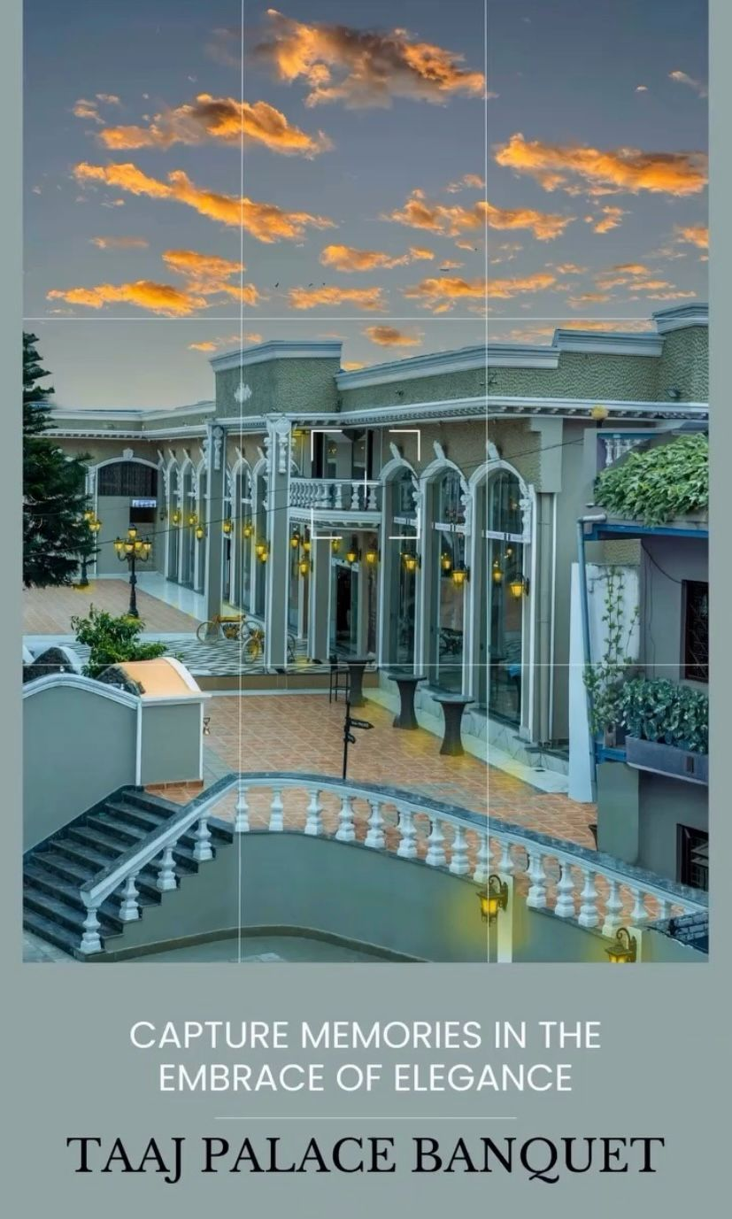

Figure Image of location Taaj palace.

-

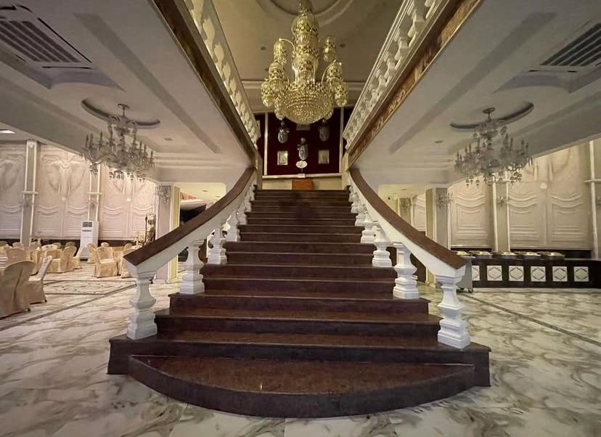

Figure Image of location indoor 1.

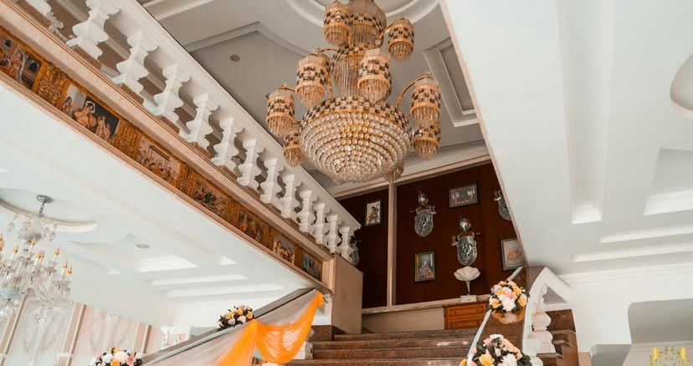

Figure Image of location indoor 2.

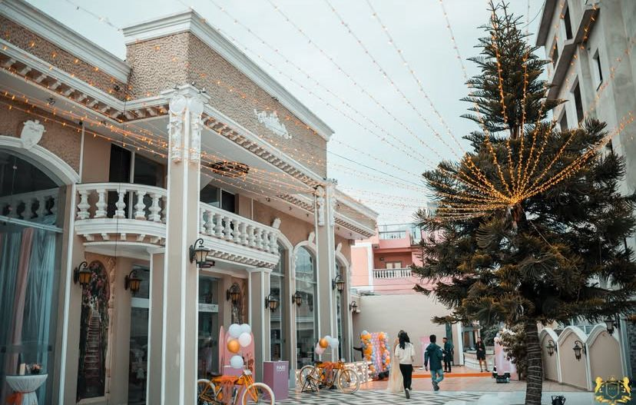

Figure Image of location indoor 3.

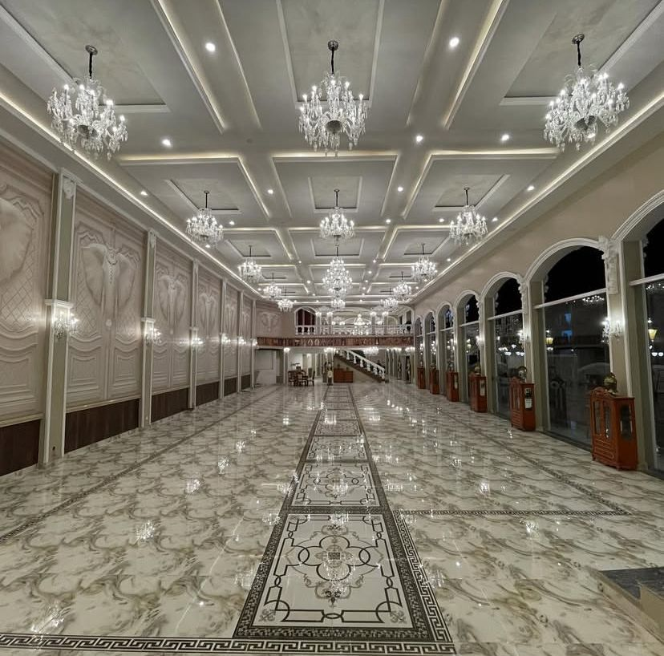

Figure Image of location indoor 4.

### Mood Board

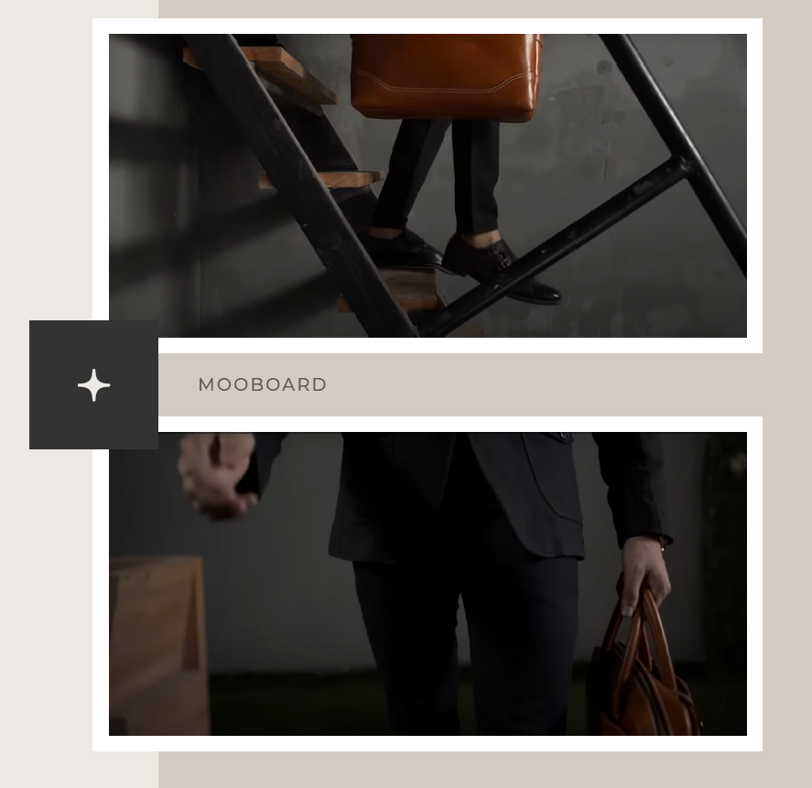

Figure Creating Reference Mood Board 1

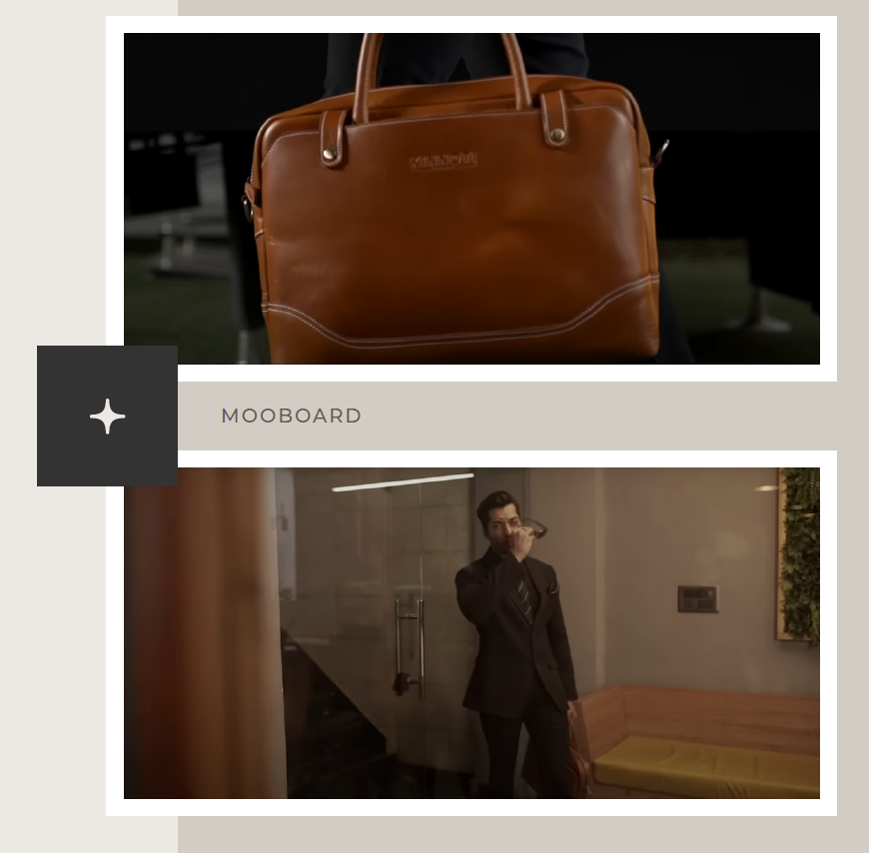

Figure Creating Reference Mood Board 2

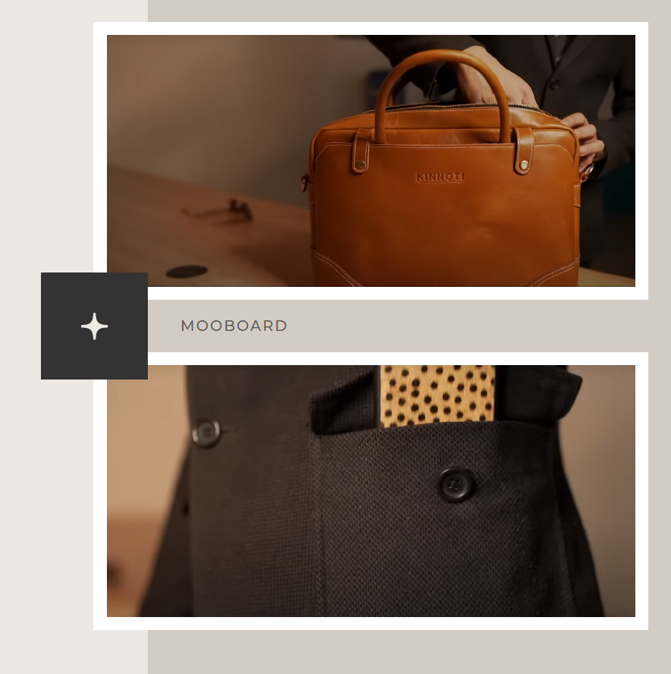

Figure Creating Reference Mood Board 3

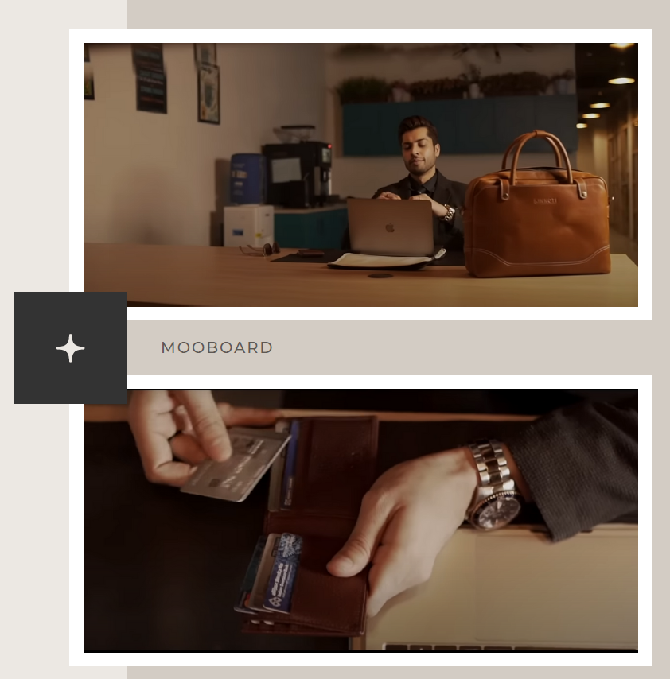

Figure Creating Reference Mood Board 4

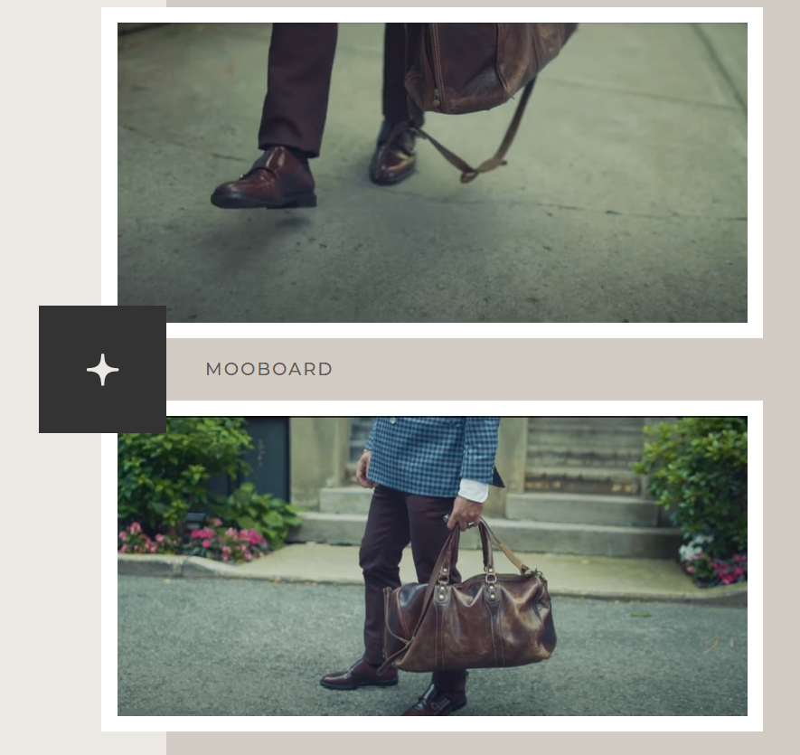

Figure Creating Reference Mood Board 5

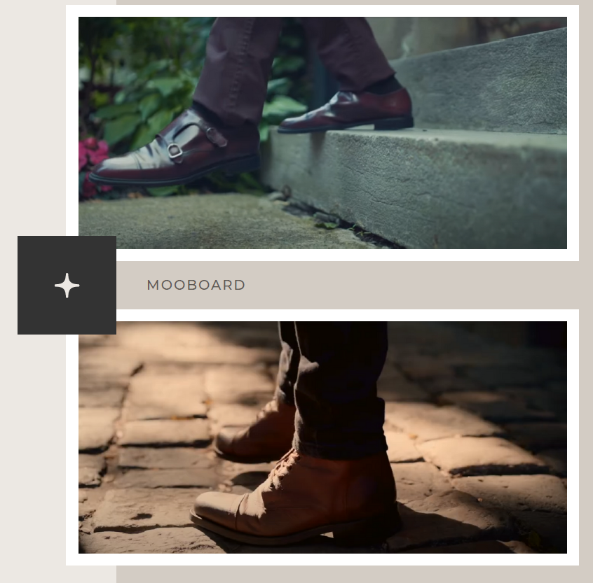

Figure Creating Reference Mood Board 6

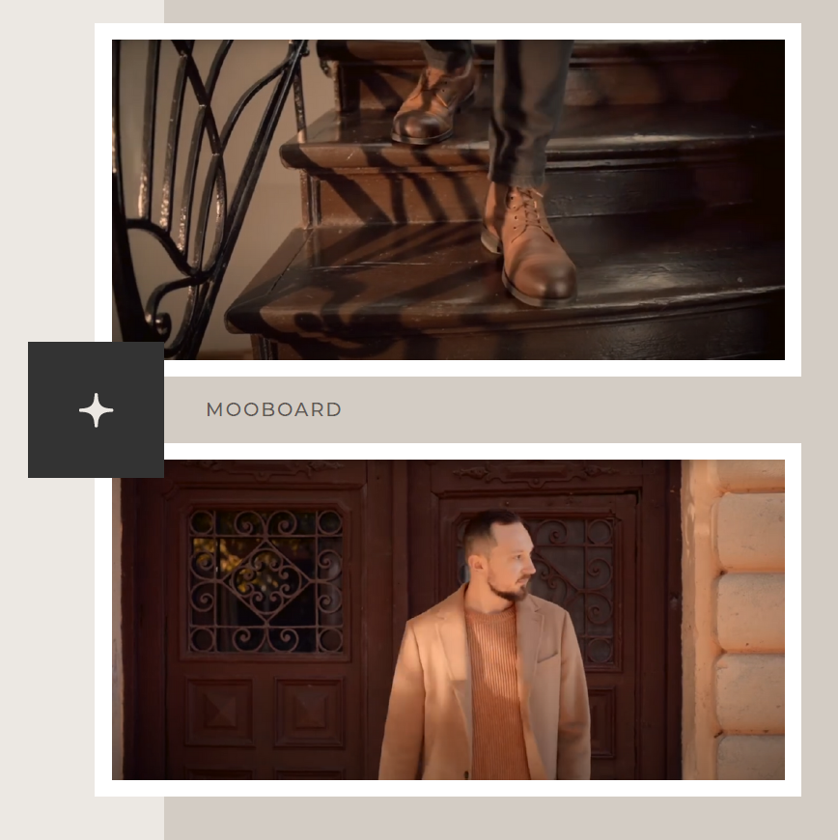

Figure Creating Reference Mood Board 7

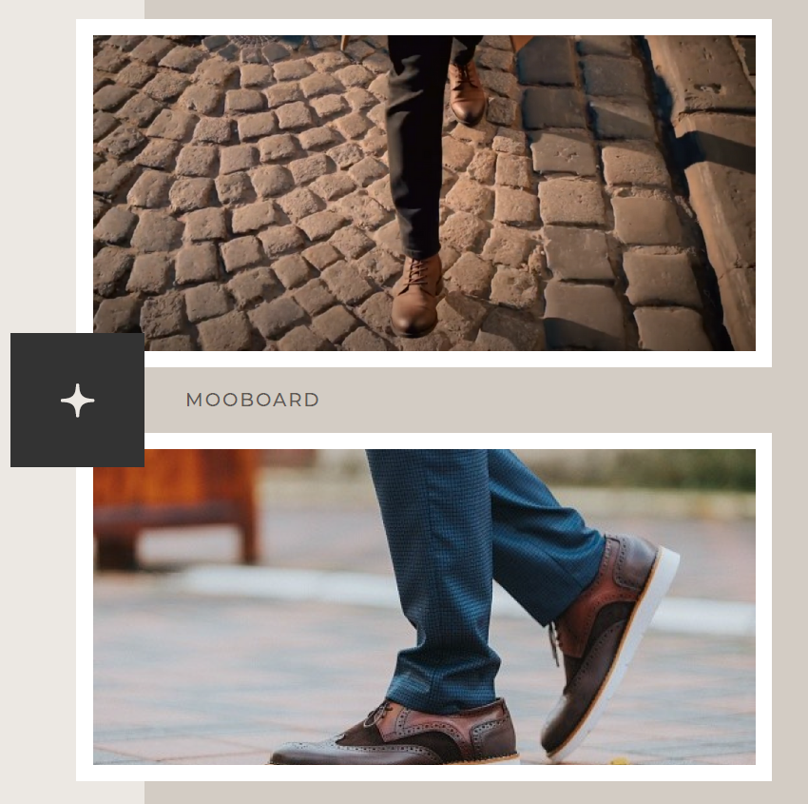

Figure Creating Reference Mood Board 8

### Wardrobe References

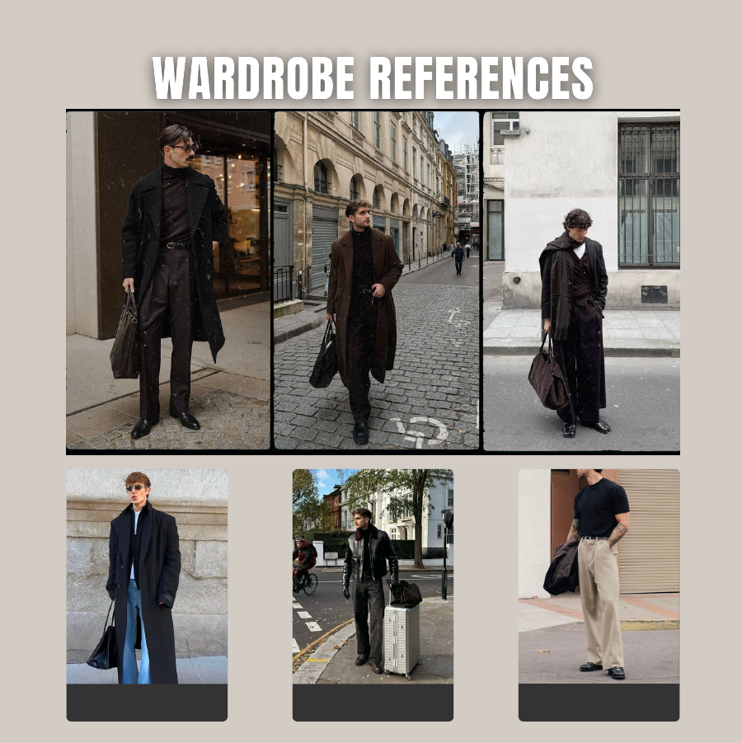

### Cast Selection

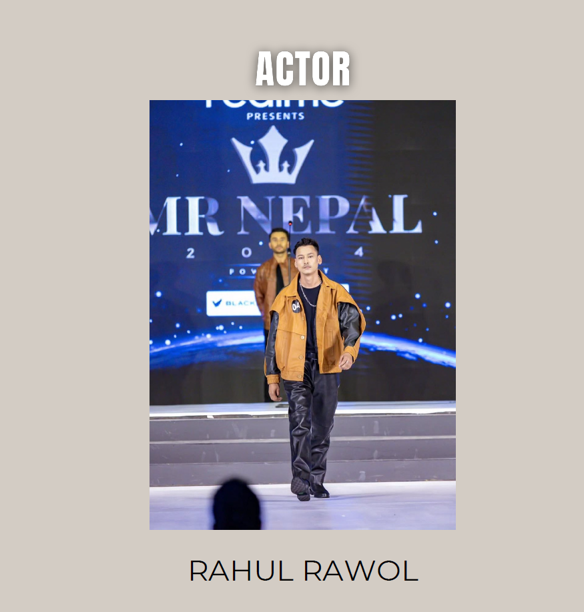

## Production

### Call sheet

|  |  |  |  |  |  |
| --- | --- | --- | --- | --- | --- |
|  |  | **Dulla Advertisement** |  |  |  |
|  |  |  |  |  |  |
| Director | Kapil Adhikari |  |  |  |  |
| Producer | Utsav thapa |  |  |  |  |
| Model | Rahul Rawal |  |  |  |  |
| Lights man | Manish |  |  |  |  |
| Cinematographer | Nawa raj Basnet |  |  |  |  |
| Assistant cinematographer | Sujit Thapa |  |  |  |  |
| Editor | Kapil Adhikari |  |  |  |  |
| Music Composer | Kapil Adhikari |  |  |  |  |
|  |  |  |  |  |  |
|  |  |  |  |  |  |
| Crew Call Time | 11:00am |  | Shoot call Time | 12:00am |  |
|  |  |  |  |  |  |
| Venue | Taaj Palace Golfutar |  |  |  |  |
| Weather | Sunny |  |  |  |  |
| End of the shoot estimated Time | 5:00pm |  |  |  |  |
|  |  |  |  |  |  |
|  |  |  |  |  |  |
|  |  |  |  |  |  |
|  |  |  |  |  |  |
| Cast | Role | Call Time | On set |  |  |
| Rahul Rawol | Lead Model | 11:00am | 11:00am |  |  |
|  |  |  |  |  |  |
|  |  |  |  |  |  |
|  |  |  |  |  |  |
| Set Requirement |  |  |  |  |  |
|  |  |  |  |  |  |
| Transport | Bike and Car |  |  |  |  |
|  |  |  |  |  |  |

### Shooting

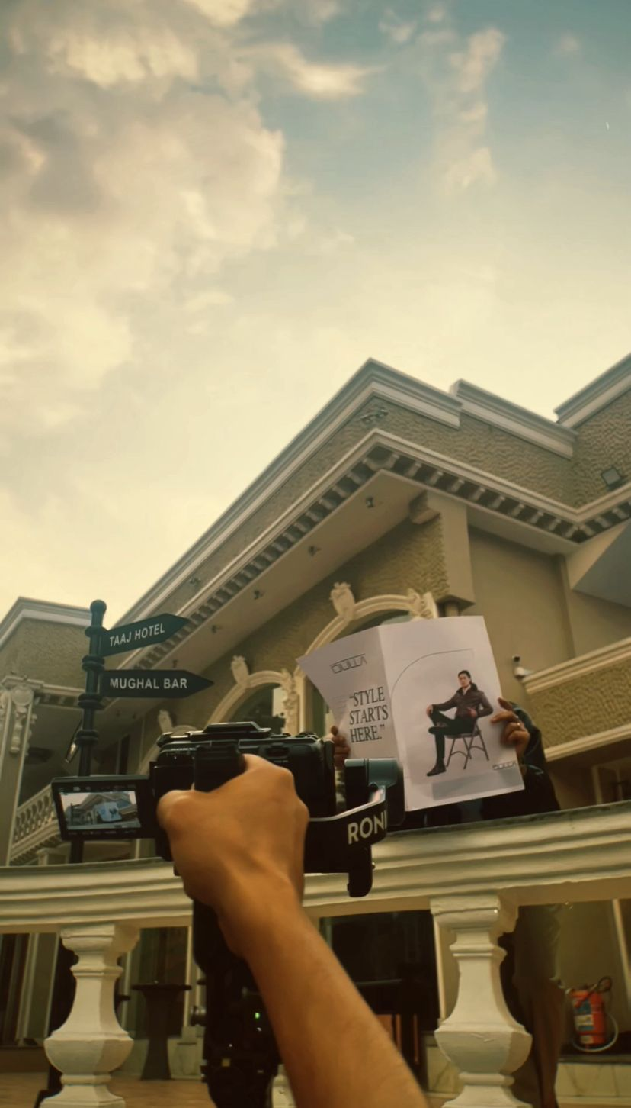

Figure Image of Shooting 1

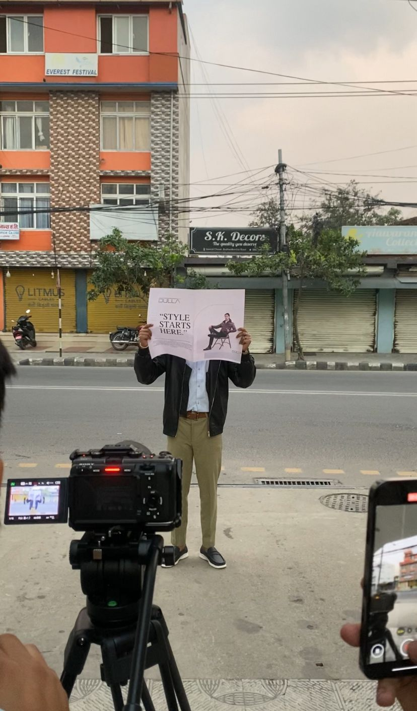

Figure Image of Shooting 2

The entire crew worked in close coordination during the shooting of the Dulla ad to ensure every shot was in sync with the brand's story and visual personality. A particular emphasis was placed on highlighting the sophistication and quality of the leather goods, such as Chelsea boots, bags, and purses, in relatable, everyday situations. They were extremely adaptable and able to go with the flow, which really helped during some of the trial-and-error aspects that took place during shooting when we would come up with things on the spot that proved to enhance the final video. The camera model, lighting and stage composition all played key roles in bringing out the products’ premium feel and reinforcing the modern, refined impression of the Dulla brand.

#### BTS (Behind the Scenes)

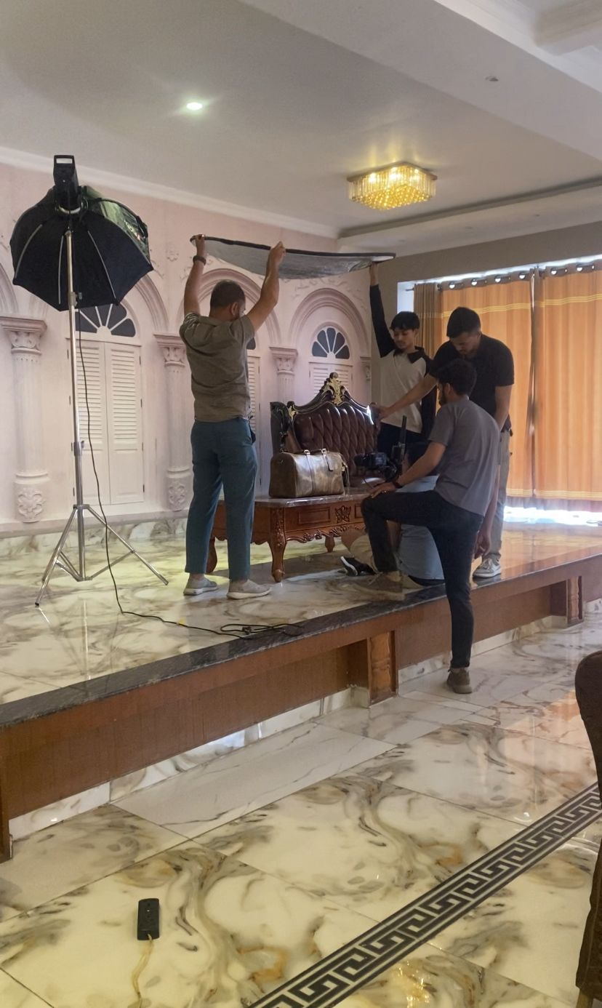

Figure Image of BTS 1

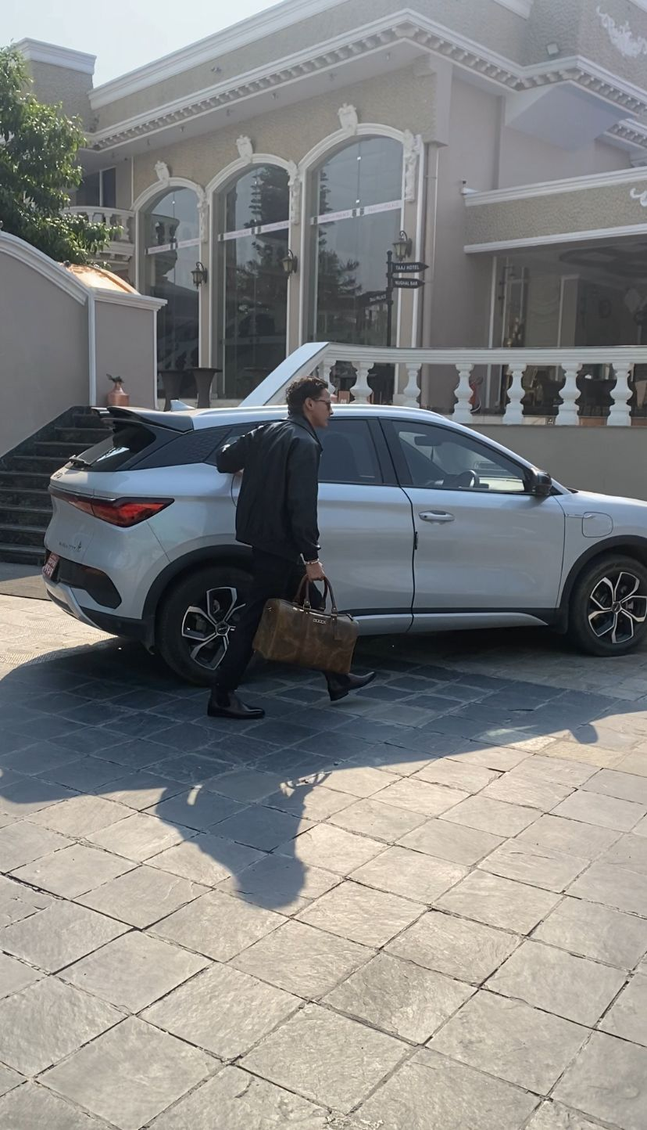

Figure Image of BTS 2

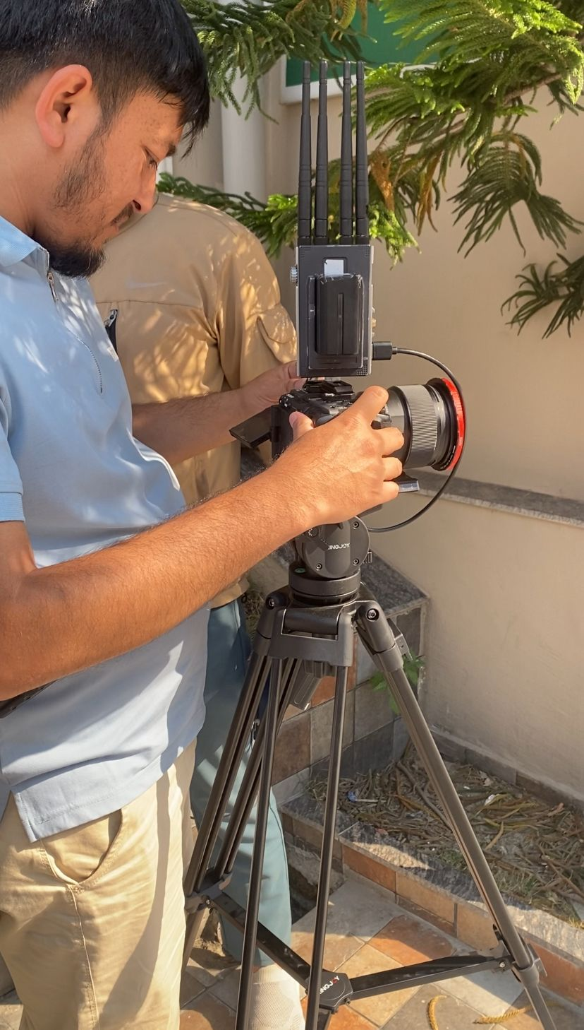

Figure Image of BTS 3

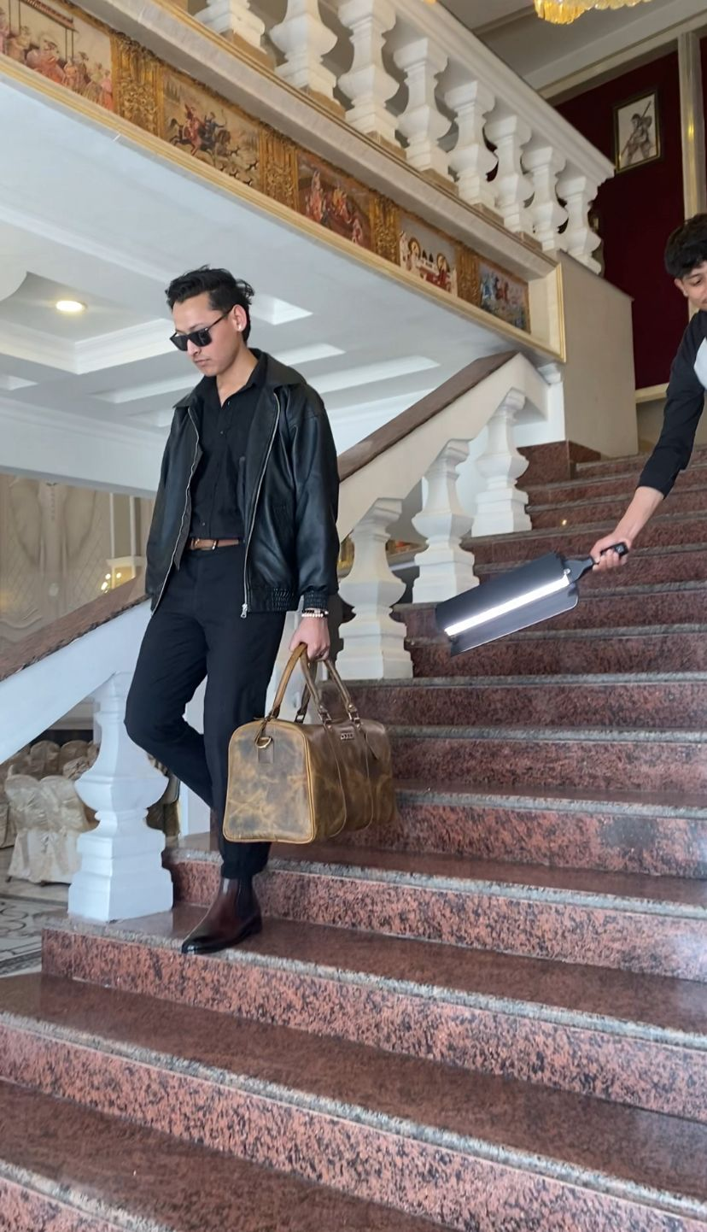

Figure Image of BTS 4

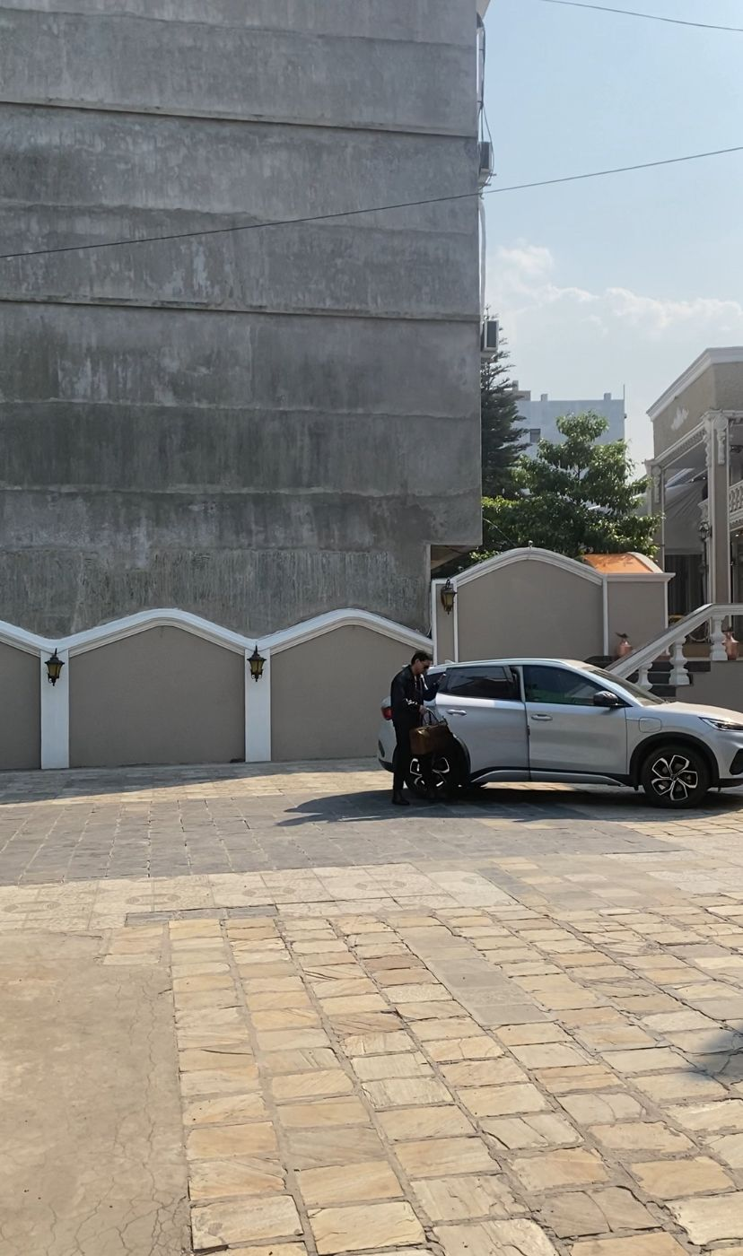

Figure Image of BTS 5

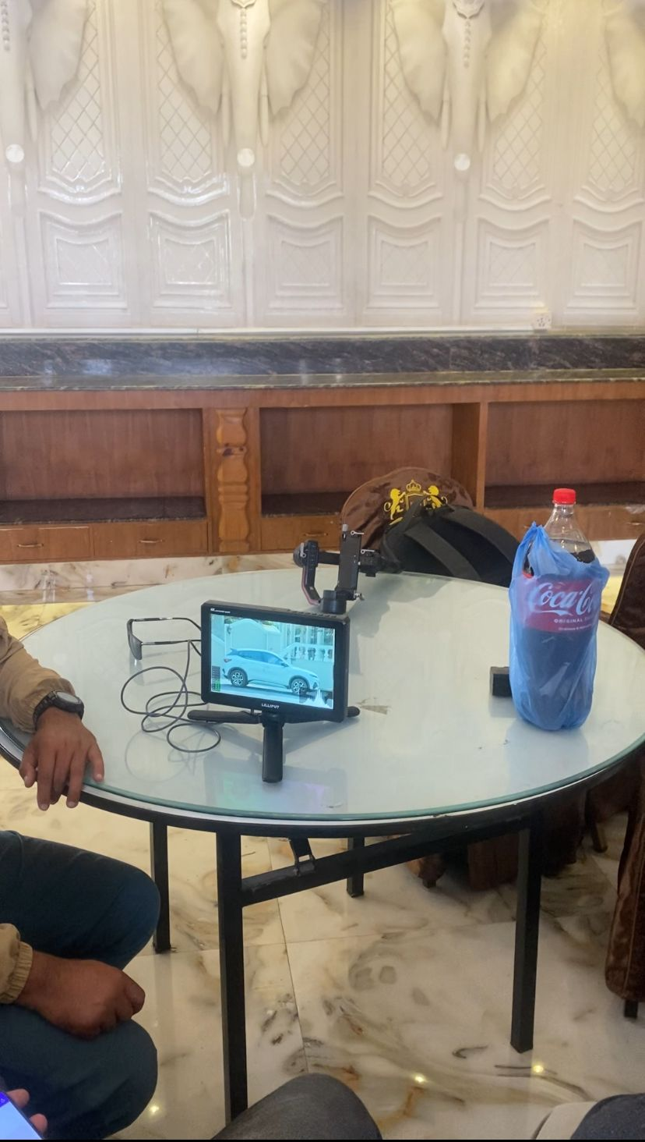

Figure Image of BTS 6

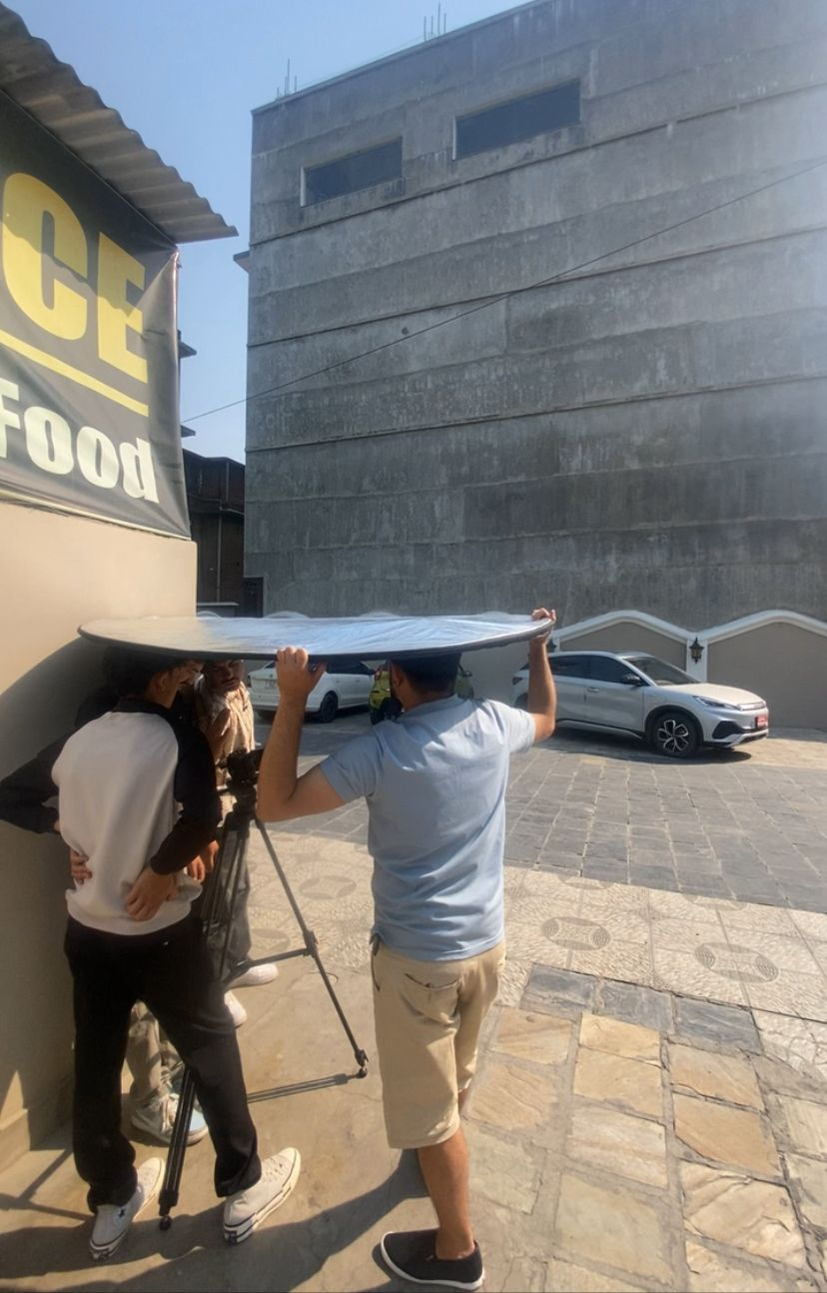

Figure Image of BTS 7

The Dulla advertising campaign was a joint venture composed of responsible that had taken over different role to make the project a reality. Setting up in the scene, lighting, and props were all done in the taaj palace, but pro camera operators were brought in to shoot the film. The support of classmates that have produced video before was great, as they helped to troubleshoot problems quickly and keep our process under control. This collaborative process, based on teamwork and shared skills, proved effective in maintaining momentum and led to the development of a slick professional outcome. Clear communication from beginning to end kept the shoot efficient and unified.

## Postproduction Phase

### Davinci Editing Process

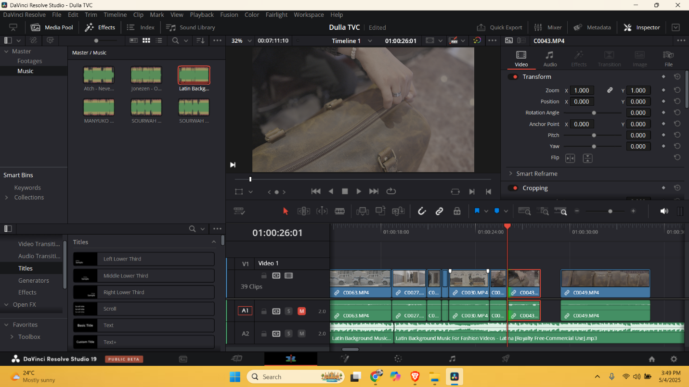

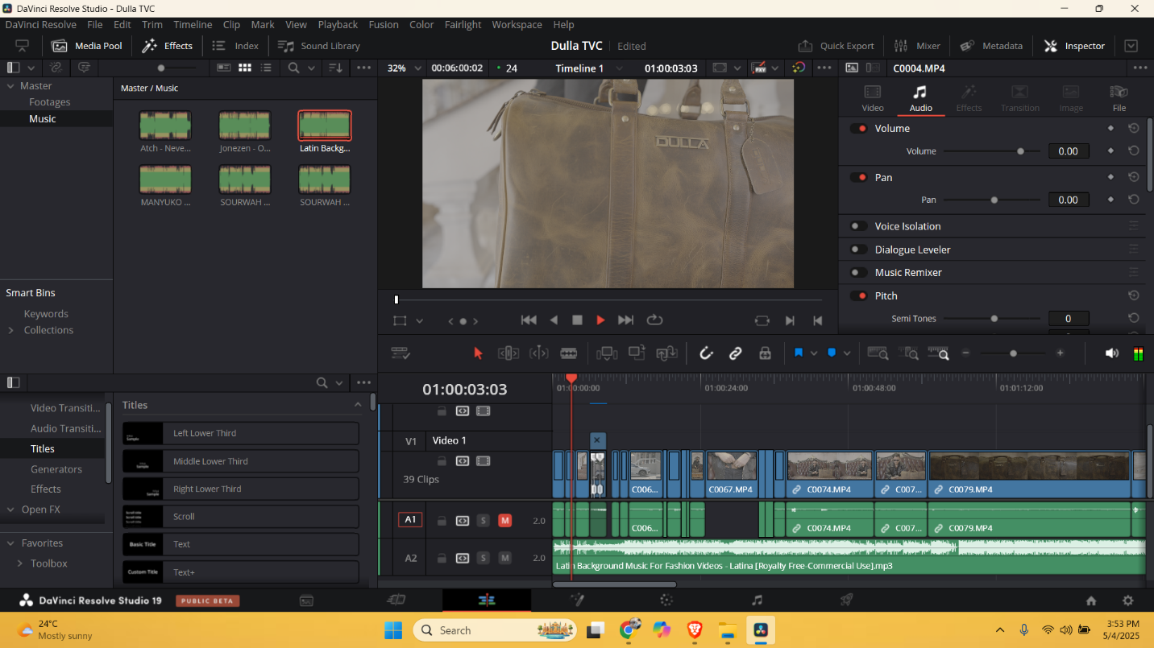

After Finishing the shoot, all the footage was loaded into DaVinci Resolve for editing. This was the step where the project moved from filming to editing. DaVinci Resolve is a great program for editing and improving video because it has many powerful tools, especially for colour correction. After importing the video, it was organized and ready for editing, starting the process of putting together the final Dulla advertisement.

After importing the video into DaVinci Resolve, I arranged the clips in order on the timeline based on the storyboard. This helped make sure the events followed the planned story. I also cut out any extra parts and long pauses to keep the video interesting and smooth. This made the story clearer and easier for the audience to follow.

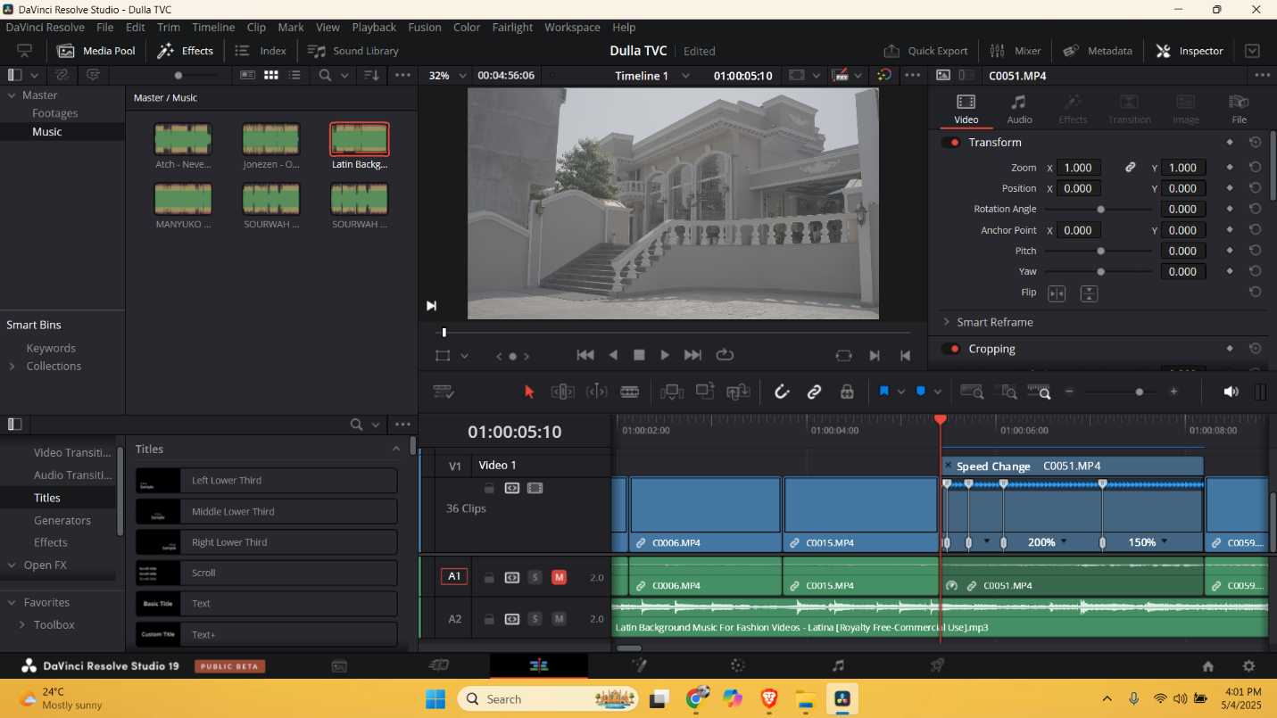

Visual pacing, product focus and brand alignment were the editing intentions when cutting the commercial in DaVinci Resolve. Once the footage was imported and organized in the media pool with labelled bins, the timeline was assembled for a clear, continuous narrative.

One shot of the car coming scene was speed ramped to give that cinematic feel and help it stand out. This helped create a more energetic environment and set a lively, playful tone early in the video. Transitions between shoe changes were treated with glitch effects to both serve the trendy, youthful barrier of the visual style of the commercial as well as to give an overall modern, cool look to the transitions of the products so that viewers wouldn't lose attention.

There were natural transitions of audio across scenes, aided by the use of normal cuts, which created a much smoother audio experience across-multiple scenes. Motion in the form of keyframed zoom-ins and beams hardly noticeable pans made it possible to animate the otherwise static shots in such a way that visual consistency over the sequence of shots is maintained.

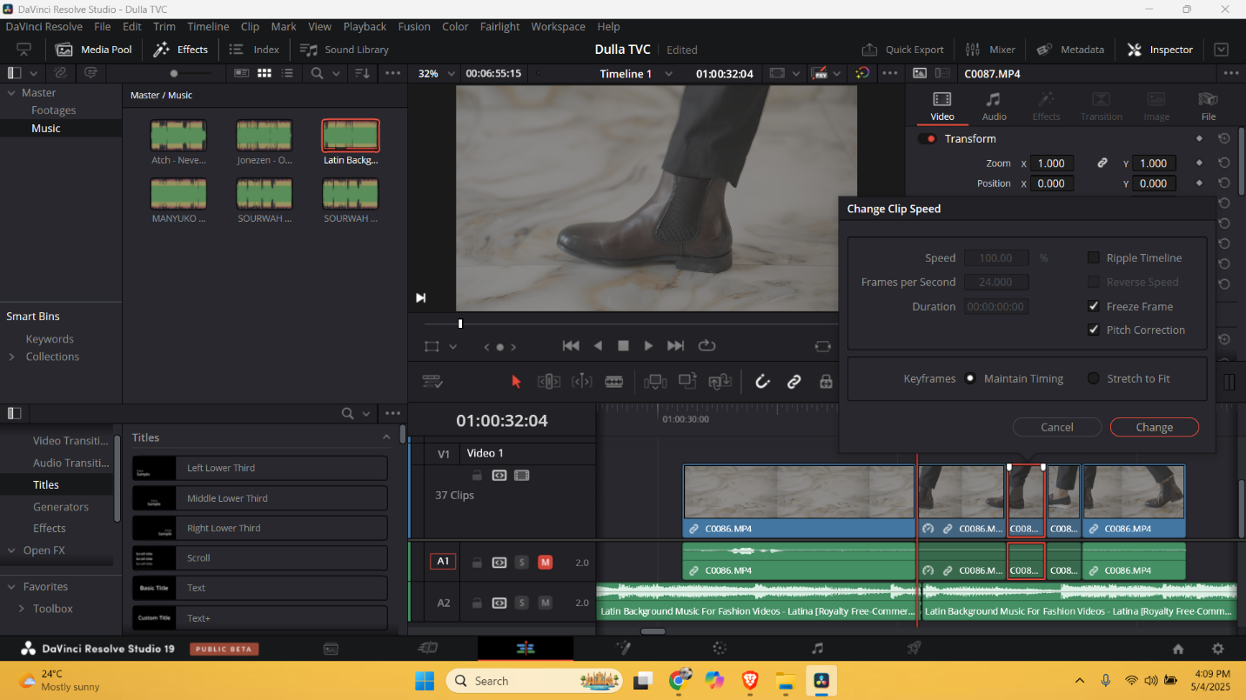

The clip speed was adjusted to create a seamless transition so that it complemented the part of the sequence where the shoe was changed. Gradually ramp the speed — either coming to a stop just before the transition or accelerating just after — which felt natural and intentional. This change made the overall subject succeed better but it did highlight the point of change without losing the flow of the moment. The speed change was synced with the beat of the background music, which further added to the rhythm and kept the product as the visual focal point during the transition time.

To change the feel of the video and make it more powerful, I added a new background music track. This new music was meant to create a different mood or bring out new emotions compared to the previous music. I picked a song that matched the images and the feeling I wanted to share in the video. By using fresh background music, I aimed to make the video more interesting and keep the audience engaged throughout.

### Colour Grading

To begin the color grading process a Color Space Transform was added to the footage, bringing it from log to S-Log3, which is fundamental for grading. This was followed by the use of multiple nodes to create a neat and streamlined workflow. A dedicated node for exposure brought back details in both highlights and shadows, another for white balance provided accurate and consistent tones across shots. We used a LUT (Look-Up Table) on an independent node to apply a stylized look that matched the brand's clean and contemporary style. Using Custom Curves, I fiddled with S-curve to make some contrast without losing the details. During this phase we monitored scopes such as the Vectorscope in order to balance our colors and keep the skin tones true to nature. This guided grading method allowed a more refined, motion picture quality, while maintaining emphasis on product and brand identity.

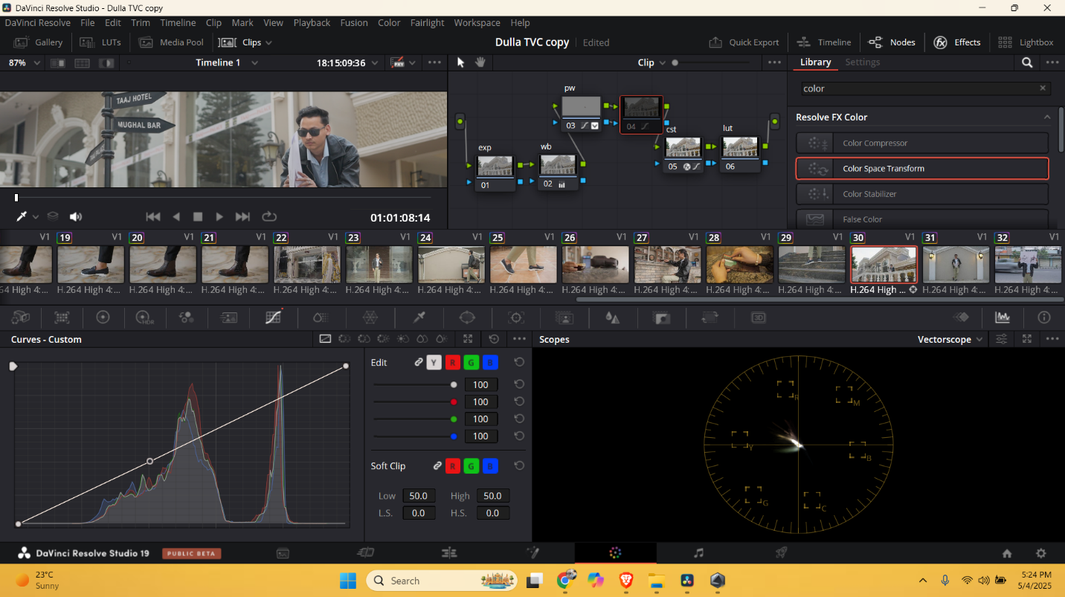

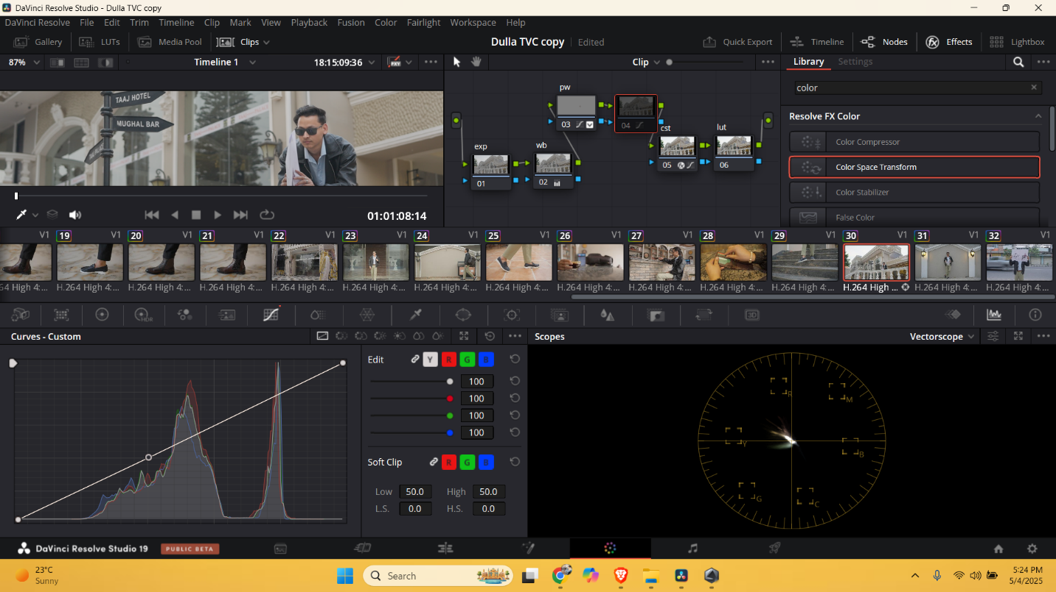

The only tools used here were individual nodes to separate different pieces of the frame followed by some more detailed grading and the application of the final LUTs. The node structure was simplified (but also expanded) with dual background and skin adjustments. One of the nodes was simply to give more control to the background, without worrying about processing over the subject, and another node was to specifically work on correcting skin tones, which is essential to making sure the skin maintains a natural and slightly consistent look despite being shot in different lighting conditions. These independent tweaks were then combined and fed through a final LUT node to bring the style together. Subtler chroma blur was then applied uniformly across each of the color channels using the blurred settings to help smooth color transitions and diminish any sharp digital edges, particularly effective in keeping skin and fine textures clean. We kept an eye on the vector scope so that skin tones were still in their proper window, so the image still looked normal and professional. Staying true to this layered approach enabled level of accuracy and polished cinematic look where the subject and product stayed clearly defined in the frame.

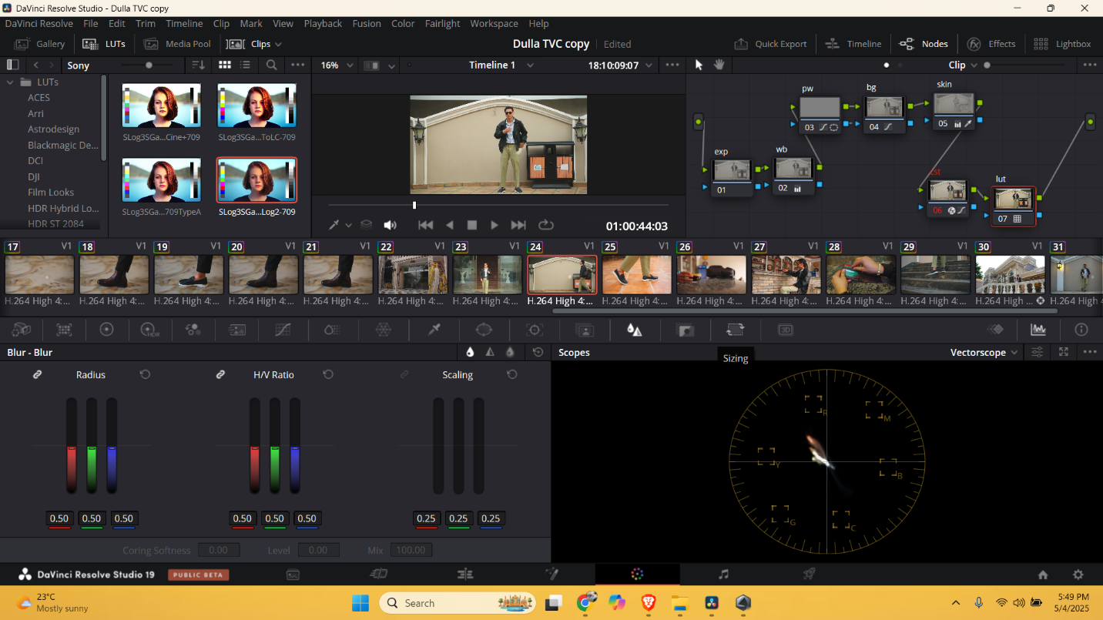

After the process that was previously mentioned relating to color grading, the next was to enhance the clarity and softness of the colors in the actual footage. Once those were done for exposure, white balance, skin tones and background a chroma blur added to taste to clean up the image just a little bit. Using the Blur panel, I created a radial blur using equal settings of 0.50 in the Radius, H/V Ratio, and Scaling for each color channel (Red, Green, and Blue). This was a way to lightly soften some color edges and ease any digital harshness, or noise, around detail areas, like faces and clothing textures.

Chroma blur also contributed to blending colors more pleasingly, resulting in a completely natural yet cinematic look. This process worked especially well to retain soft, professional-looking skin tones, without introducing over-sharpening or detail loss. We kept an eye on the Vector scope to balance saturation and make certain skin tones remained within the vector line. This extra level of detail rounded the grade off, enabling the visuals to fall in line with the premium, luxe aspirational aesthetic that was happening with the Dulla brand itself.

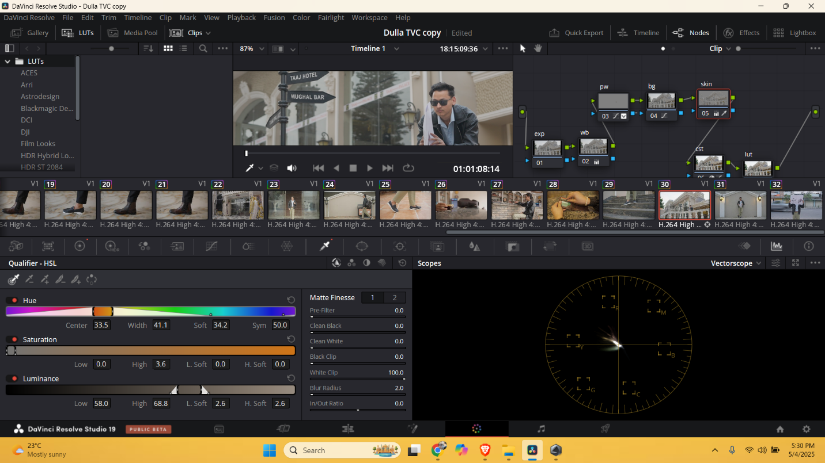

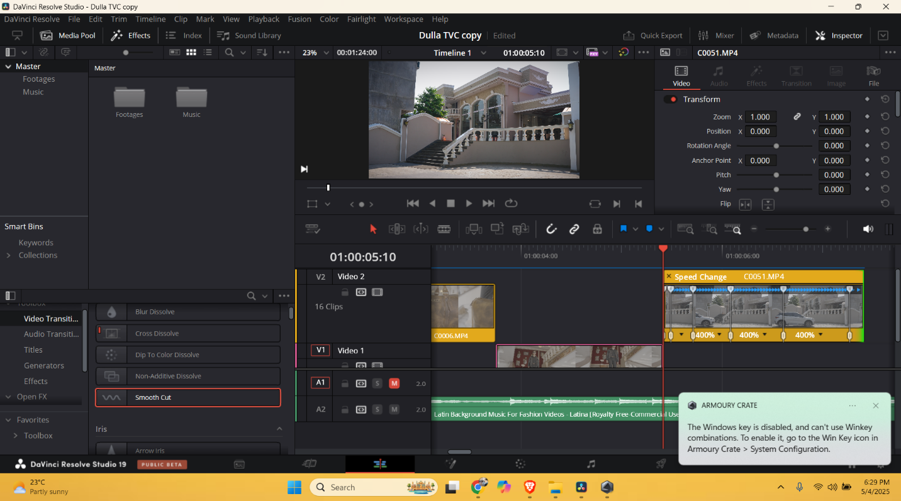

### Final Rendering

The editing, audio mixing, and color grading of the Dulla advertisement was all done in DaVinci Resolve, followed by a review. All video clips were sequenced properly, transitions were smooth, color grading tone was same with color grading desired visual. Detailed checks were made, ensuring the Dulla branding, product close-ups, and visual text all reflected the brand identity accurately. After I settled on the timeline, we brought the project to the Deliver page and finely tuned the export settings. The final render was at MP4 in the H.264 codec, with a resolution of 1920x1080(Full HD), and 25 fps, according to the requirement in the production. After that, the project was incorporated to the render queue, and the rendering method was started. Post-rendering, the final video was checked on the media player to ensure audio and video output were error-free. The finished file was backed up, so it was ready to be released to be made available through their digital channels, and thus a clean, professional delivery of the Dulla brand message was achieved.

# Problems and problem solving

## Cancellation of shoot

The original shoot date for the Dulla advertisement was set, but it had to be canceled because the model was unavailable. Due to this, I reached out to a friend who kindly helped me find a replacement model. This caused a delay in the production schedule, as I had to coordinate with the new model's availability. Despite these challenges, I made sure to adjust the timeline and ensure everything was in place for the rescheduled shoot, ensuring the project continued without major setbacks.

## Execute the design of music in reason.

For Dulla, at production level, I first considered composing original music through Reason, an extensive full-service digital audio workstation with a wide range of multi-functional options. The output compositions while impressive s wasn’t quite what was required in terms of the intended emotional tone and thematic components for the commercial.

I also replaced the music with copyright-free music that fit with the tone of the advertisement more appropriately. This choice not only meant the soundtrack complemented the visual storytelling, but also allowed the freedom to choose tracks that elevated the advertisement's impact.

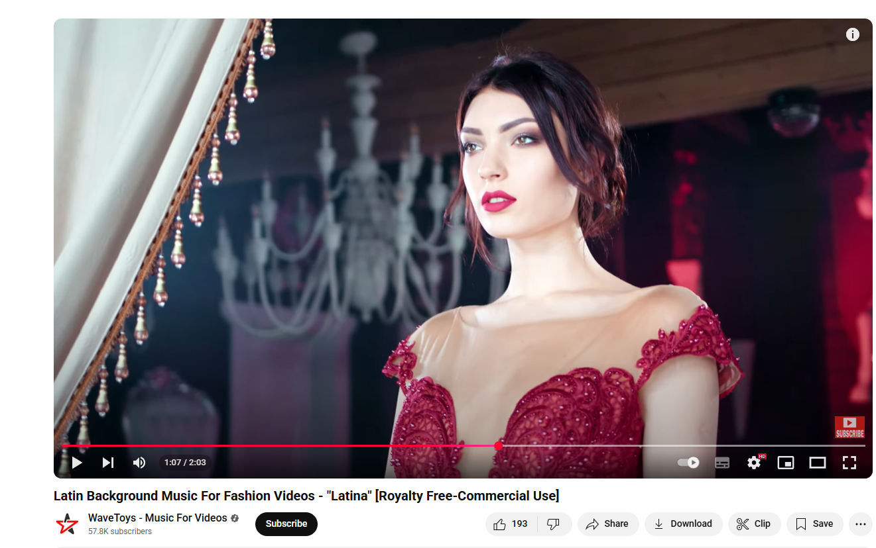

(Videos, n.d.)

Figure Reference music for dulla commercial

In addition, it was also simply a lot more practical to use royalty-free music, as the risk of copyright infringement and the cost of including music to your work would be eliminated. This enabled a more streamlined process, allowing high quality content to be delivered without sacrificing any creative vision.

# Resources

## Gears

### Production Gears

* Sony FX 3
* Gimble
* Tripod
* Lighting
* LCD lilliput

### Postproduction gears

* Acer Nitro 5,12th Gen Inte (R) Core(M) 15-12450- (12 CPUs), ~2.56Hz

## Software

* Davinci
* After effect

## Human Resources

Director: Kapil Adhikari

Casts: Rahul Rawol

Production: Manager  
camera Man: Sujit Thapa, Nawaraj Basnet

**Main Props**

* **Dulla Leather Bag** – shown during the commute or office scenes.
* **Dulla Boots or Casual Shoes** – visible as part of the character’s outfit
* **Dulla Leather Wallet** – used during the coffee shop payment scene.

# Testing and Findings

## Testing

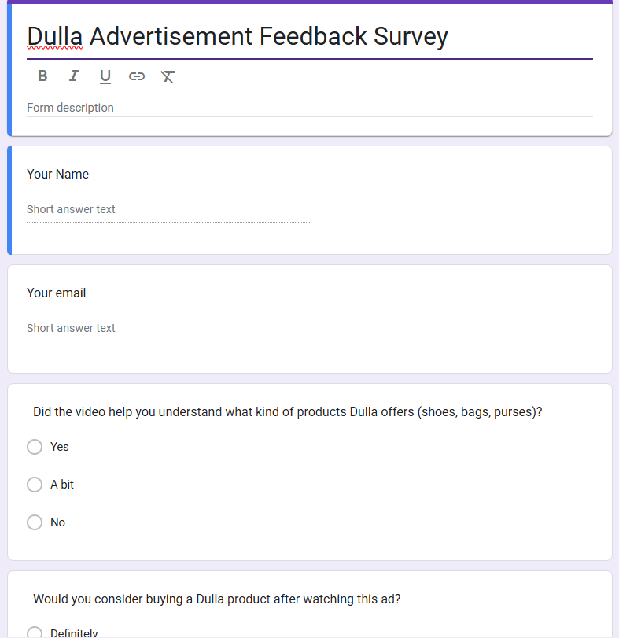

Figure Image showing Testing

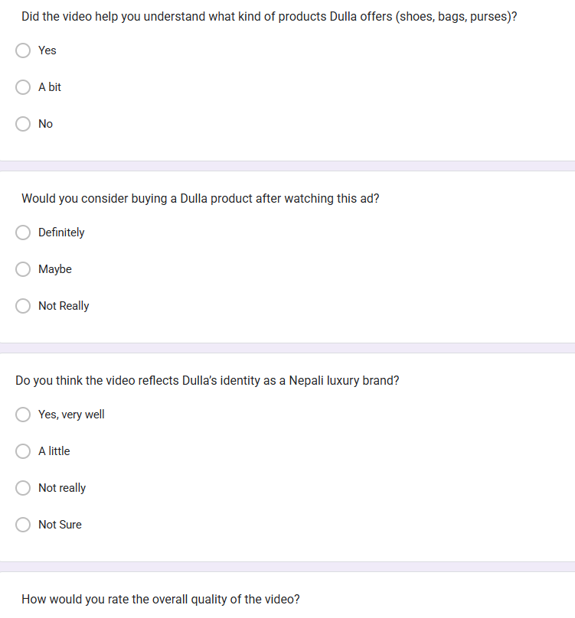

Figure Image of Survey 2

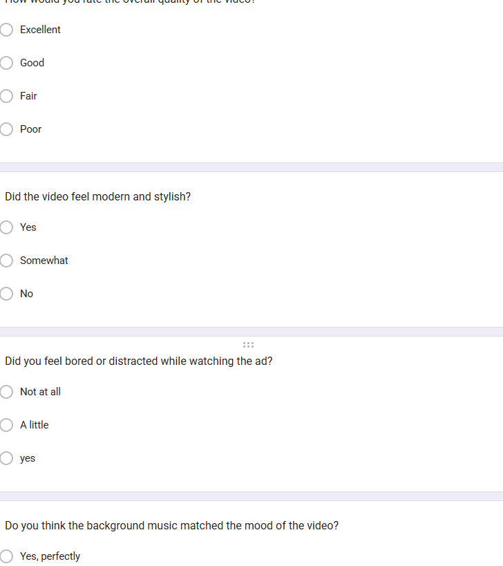

Figure Image of Survey 3

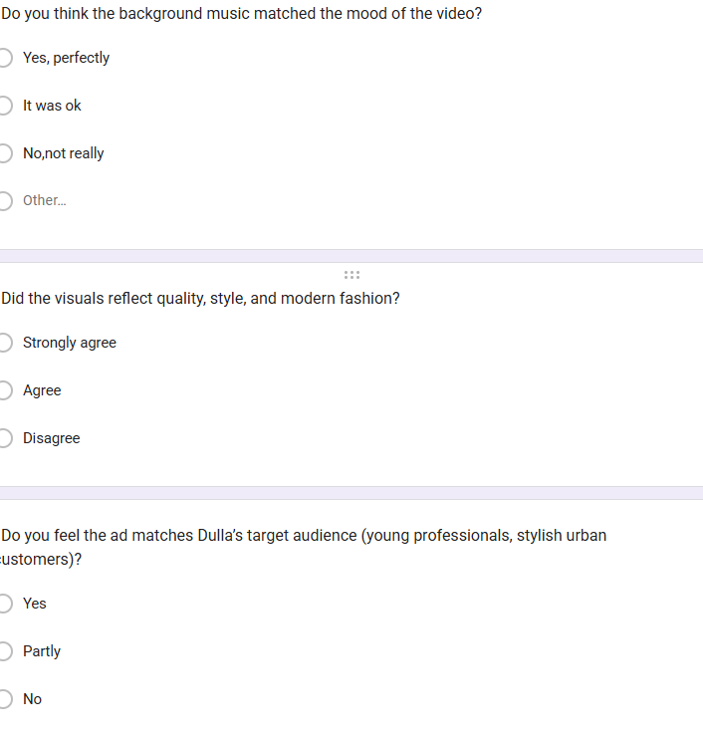

Figure Image of Survey 5

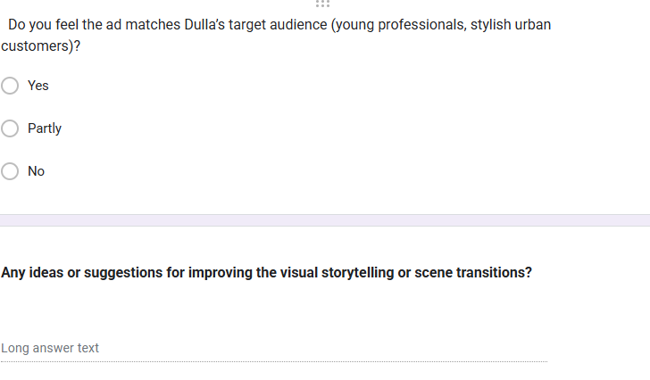

Figure Image of Survey 6

## Feedback

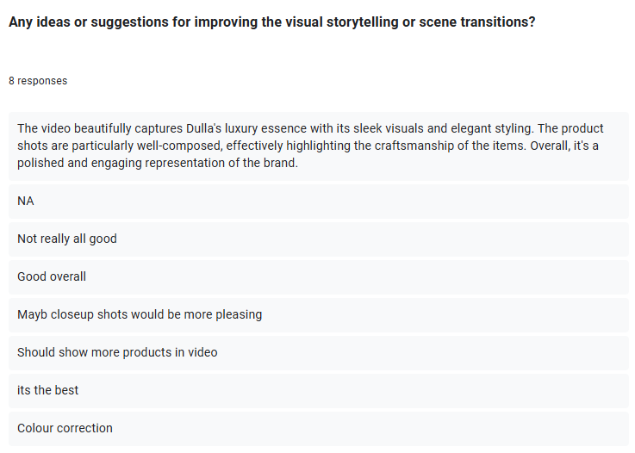

Figure People Giving Feedback on video

## Third Party Evaluation

### Friend 1

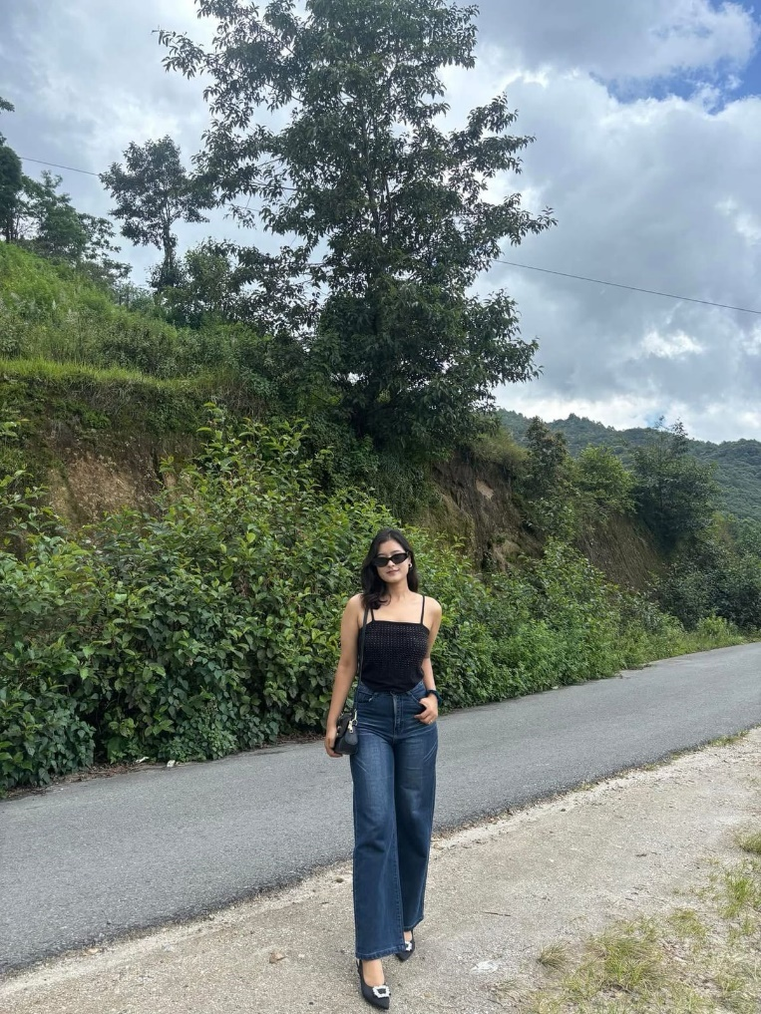

**Zoya Bhandari**

great job with this project! I’m extremely impressed with how professionally it all came off. The visuals are clean and classy, and I think the way that you’ve treated the brand is so sophisticated. Your hard work in the detail and storytelling really shines. It´s all so natural Really well done!

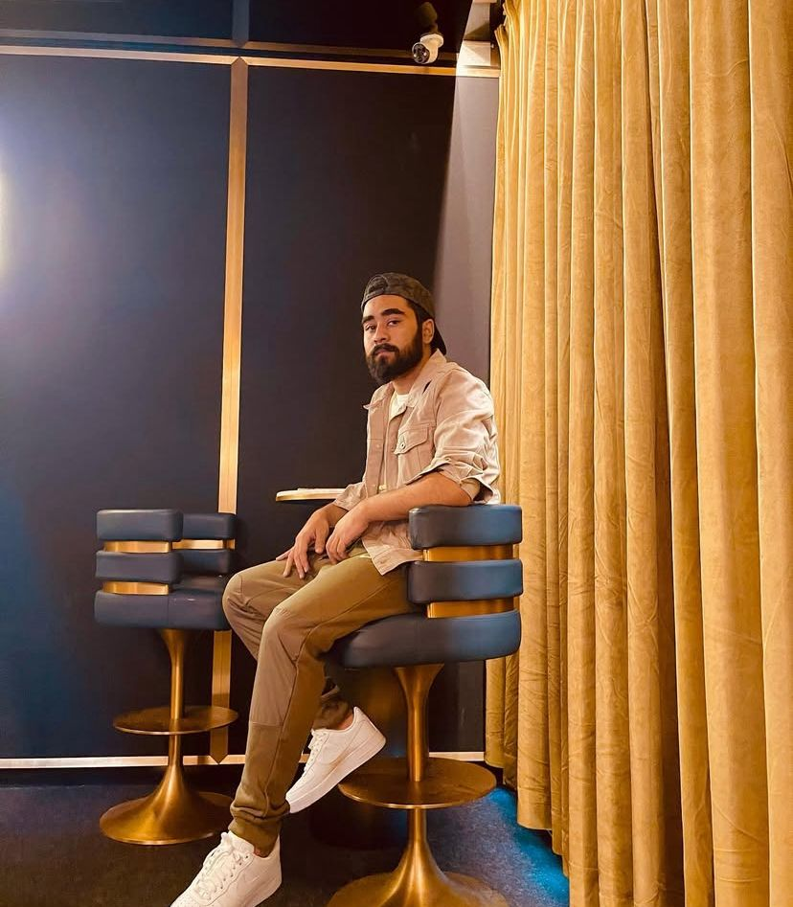

**Nischal Thapa**

your work is like serious next level. The shots are well-framed and the transition is super slick. I could see that you had really thought everything through. The video has an extremely polished feel to it and it makes sense with Dulla’s style. You’ve done so good, so proud of you!

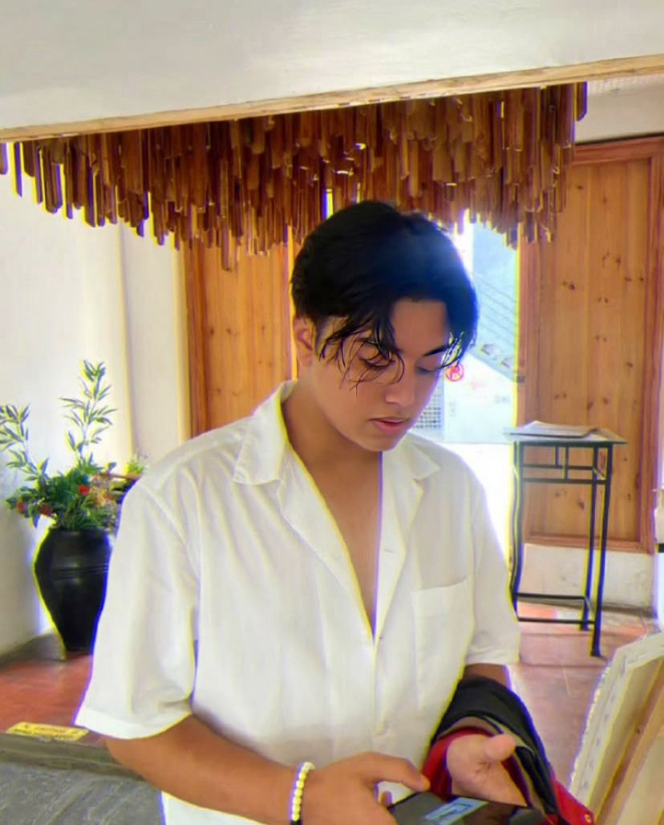

**Ansol Dangol**

I loved your video! It felt very balanced and elegant. The music, visuals, and editing all worked so well together. It was so nice to watch nothing felt overdone. You really nailed it with the mood and style. You’ve done such a great job, keep it up!

# Conclusion

Throughout this module, the focus was on producing a commercial advertisement centered around Dulla leather shoes, with the aim of showcasing their quality, style, and connection to everyday urban life. The project began with detailed planning, including research, concept development, and storyboarding to create a strong visual narrative that highlights how Dulla shoes fit into the lifestyle of a modern professional.

In post-production, DaVinci Resolve was used for both editing and color grading. Each clip was carefully arranged and refined to ensure a smooth narrative flow and professional visual tone. Color grading played a key role in enhancing the aesthetic of the video and giving it a clean, polished look that matches the brand’s identity.

To elevate the brand presentation, the Dulla logo was animated using Adobe After Effects, giving the video a professional finishing touch. This combination of editing, grading, and motion graphics brought the entire project together in a cohesive and engaging way.

Feedback sessions with mentors and peers helped refine the final cut, and continuous improvements were made throughout the process. Beyond technical execution, the project also helped develop essential skills like time management, visual storytelling, and attention to brand detail.

In conclusion, this commercial project served as both a creative and technical learning experience. From concept to final delivery, it highlighted the importance of planning, editing precision, and brand-focused storytelling in delivering a high-quality advertisement for Dulla leather shoes.

# Bibliography

everpost, n.d. *How to create a mood board for a video project.* [Online]   
Available at: https://www.everpost.com/blog/how-to-create-a-mood-board-for-a-video-project/

kinnoti, n.d. *Kinnoti Leather Bag Commercial Buy Leather Bags Online.* [Online]   
Available at: https://www.youtube.com/watch?v=7PVpaO_-QPQ

logo, D. R., n.d. *DaVinci Professional Editing, Color,.* [Online]   
Available at: https://www.blackmagicdesign.com/products/davinciresolve

paul, A., Sep 18, 2024. *5 Tips to Make Cinematic Product Commercials.* [Online]   
Available at: https://www.youtube.com/watch?v=jt6DVwCwZPk

Ramotion, Aug 25,2023. *Brand vs Branding vs Brand Identity: Exploring the Distinctions and Significance.* [Online]   
Available at: https://www.ramotion.com/blog/brand-branding-brand-identity/  
[Accessed 29 Aug 2024].

TWIZE, C. -. B., Apr 16, 2025. *How to light a on a budget I Cinematic Lighting and Color Grading Breakdown.* [Online]   
Available at: https://www.youtube.com/watch?v=63yVUUX_Q-4

Videos, W. -. M. F., n.d. *Latin Background Music For Fashion Videos.* [Online]   
Available at: https://youtu.be/UdpzLW-jnQE?si=cjiDjn23j4mFULav

Wikipedia, n.d. *MoodBoard.* [Online]   
Available at: https://en.wikipedia.org/wiki/Mood_board

# Appendix

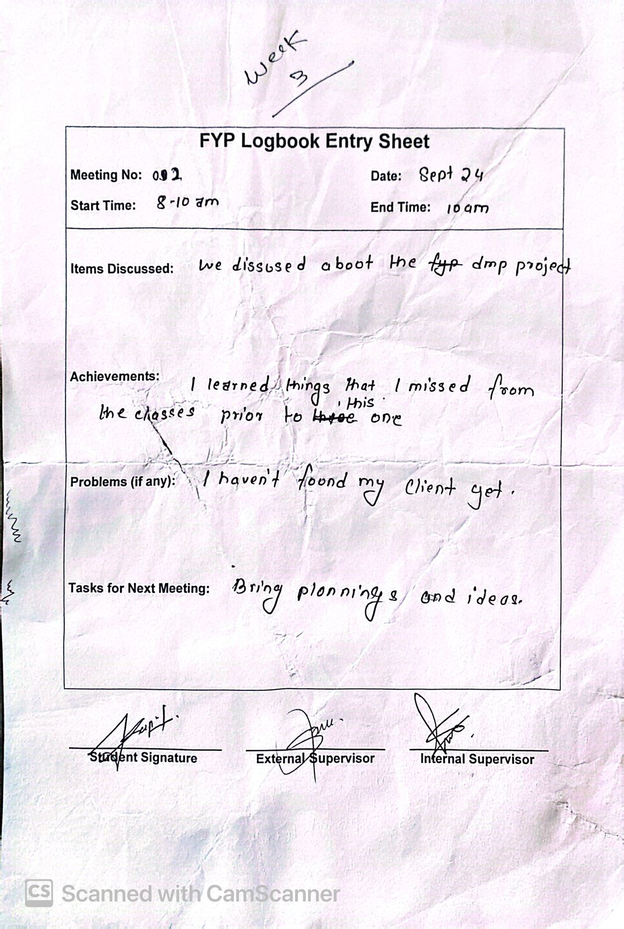

Figure Image of logsheet1

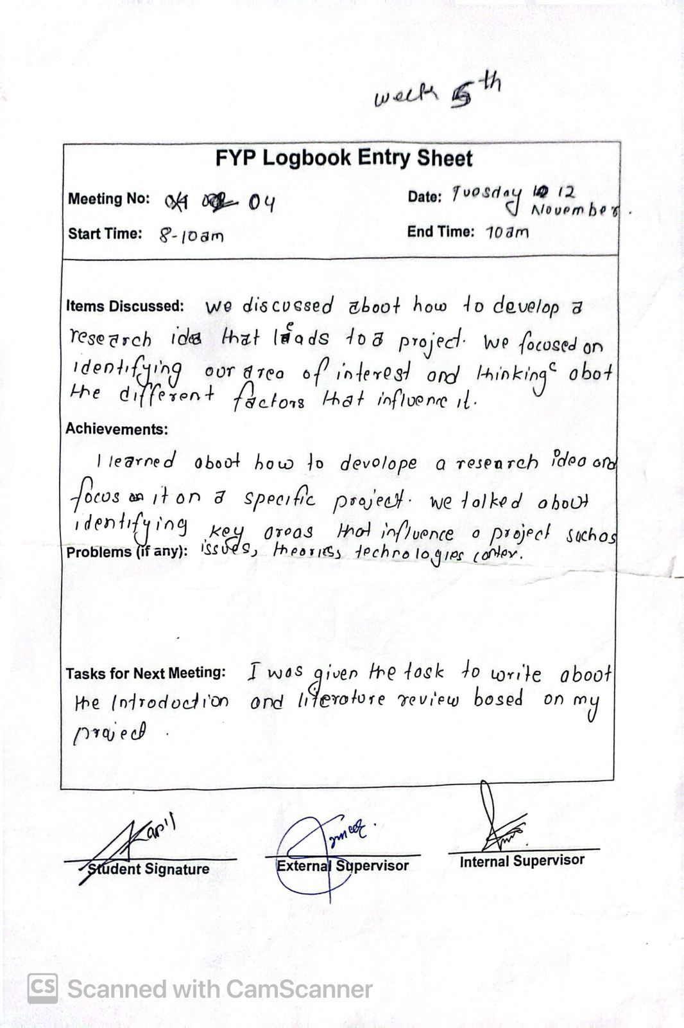

Figure Image of log sheet 2

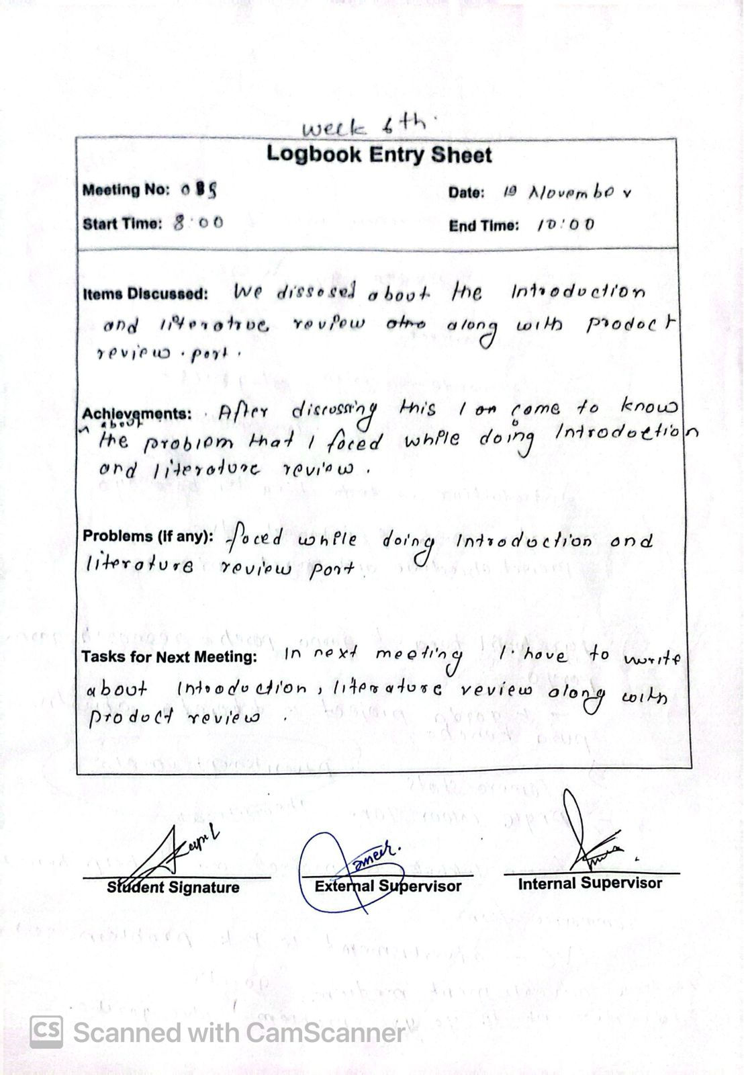

Figure Image of log sheet 3

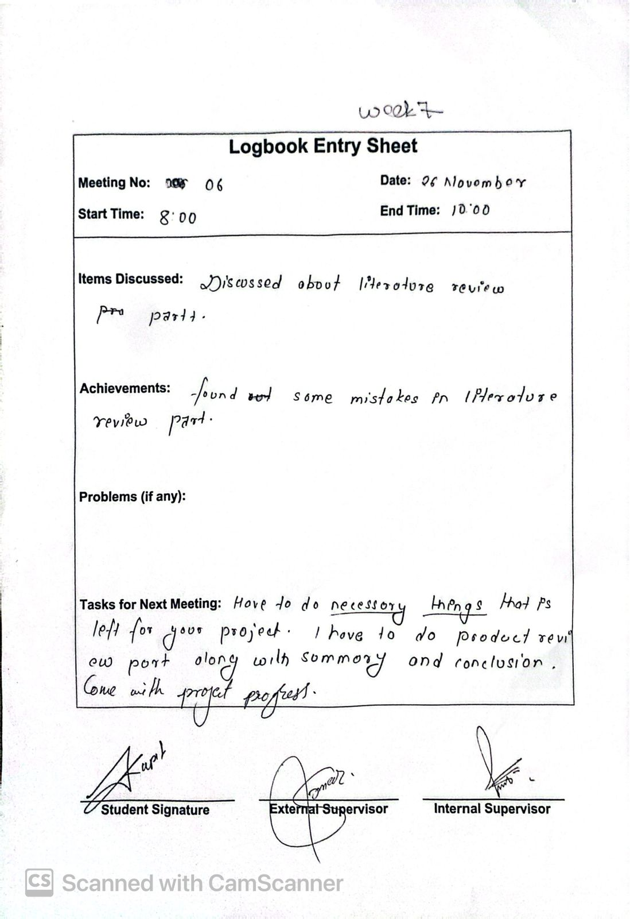

Figure Image of log sheet 4

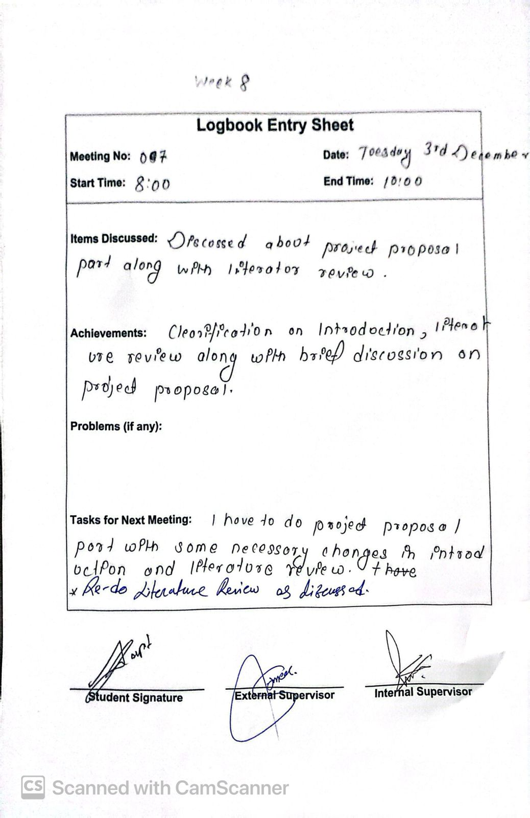

Figure Image of log sheet 5

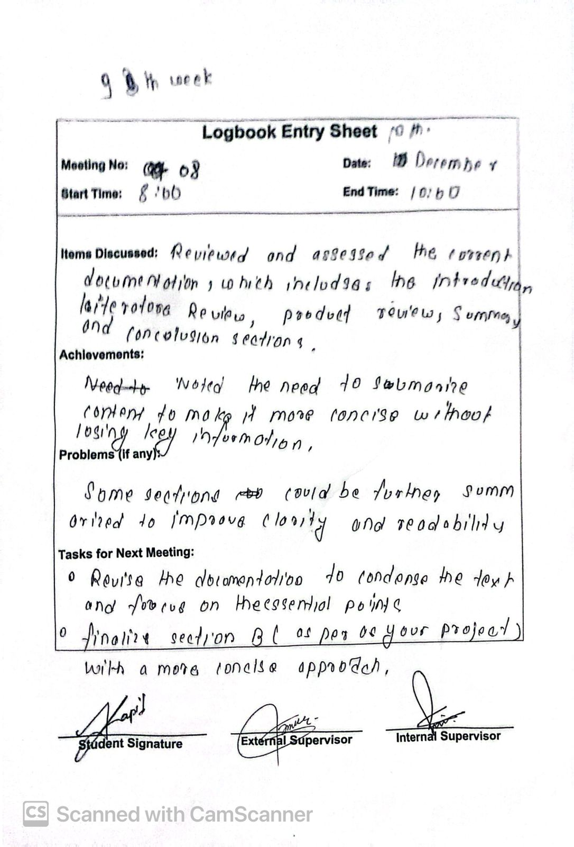

Figure Image of log sheet 7

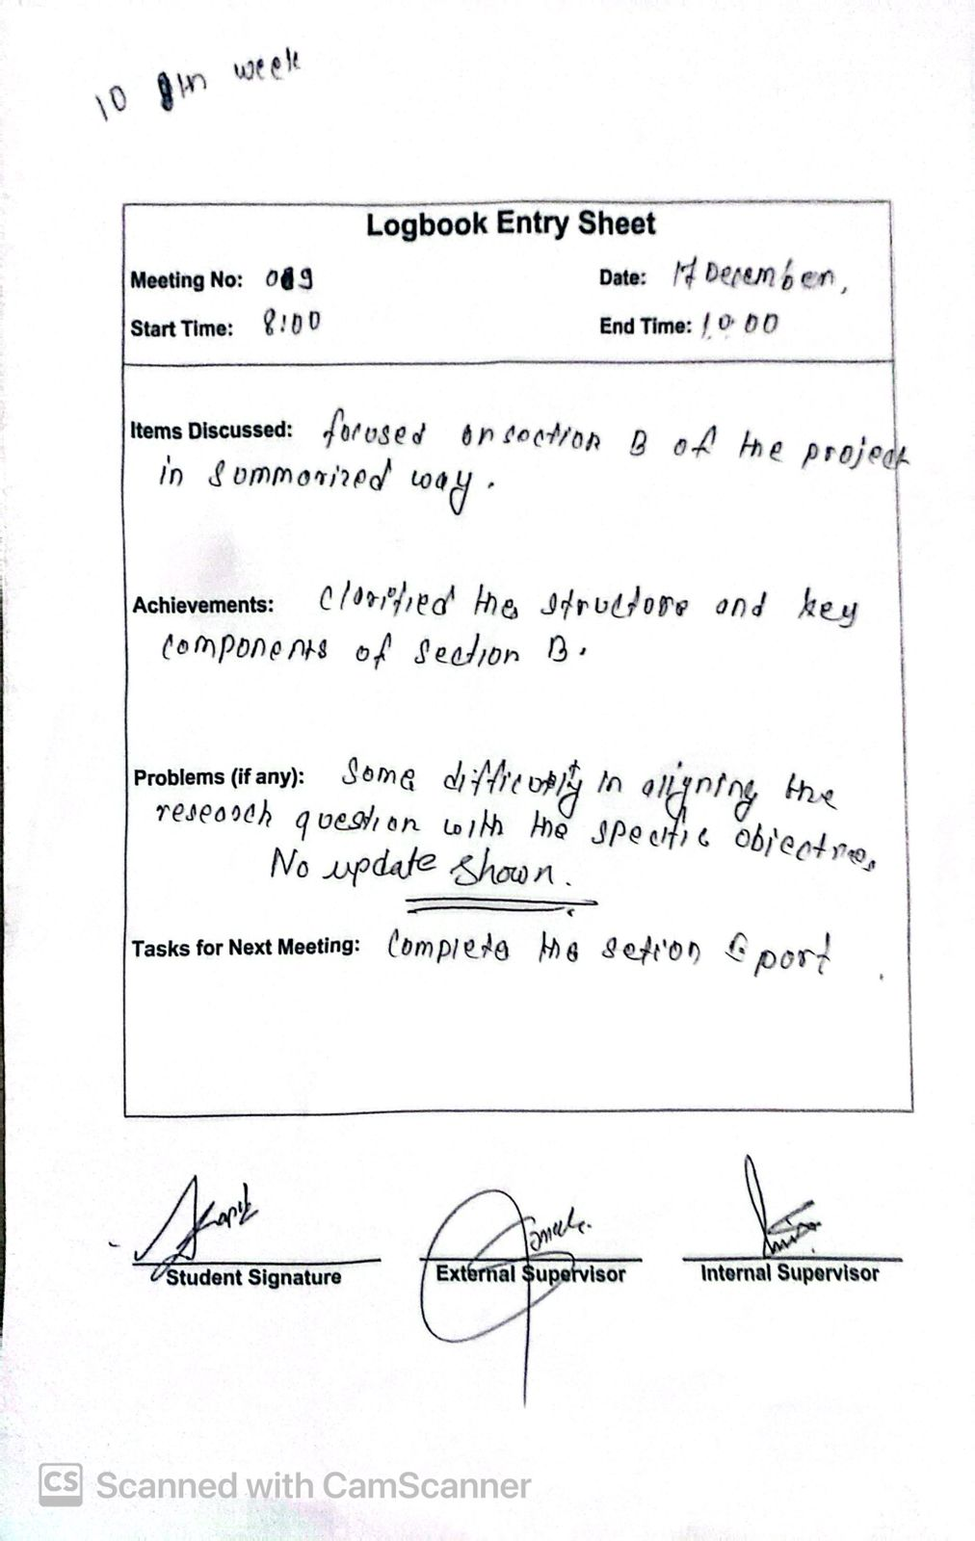

Figure Image of log sheet 7

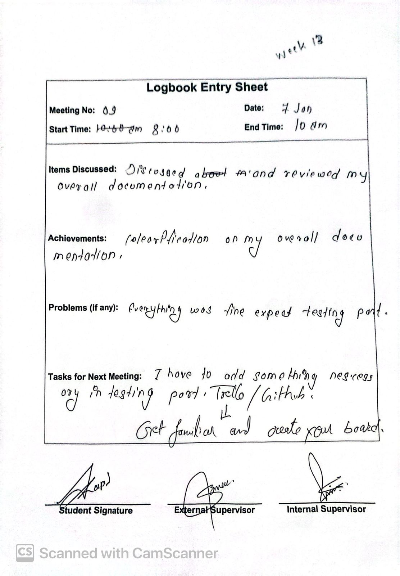

Figure Image of log sheet 8

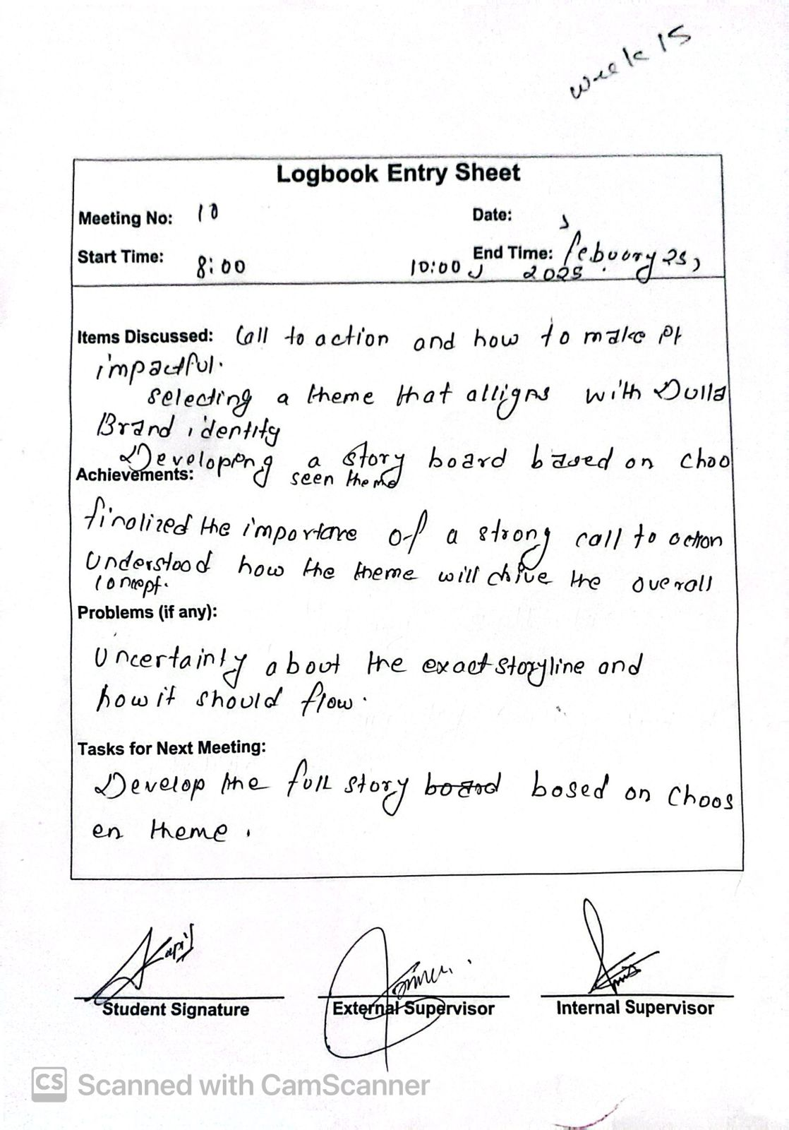

Figure Image of log sheet 9

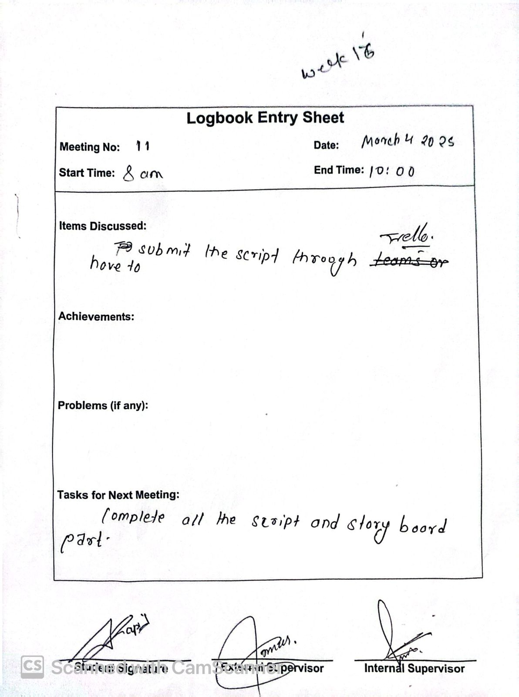

Figure Image of log sheet 10

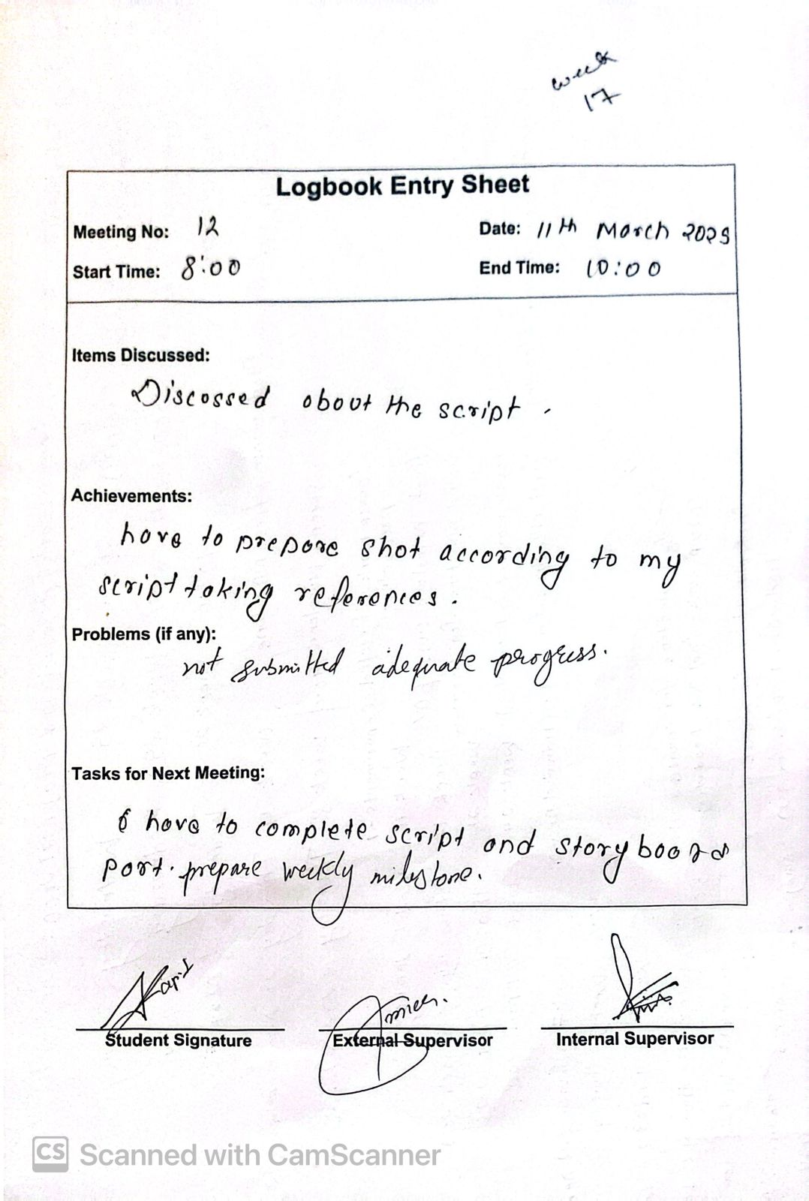

Figure Image of log sheet 11

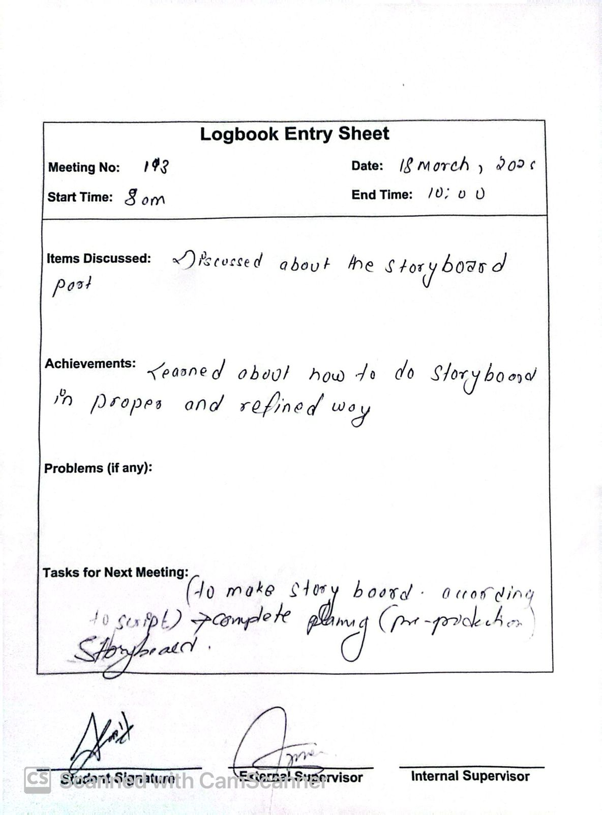

Figure Image of log sheet 12

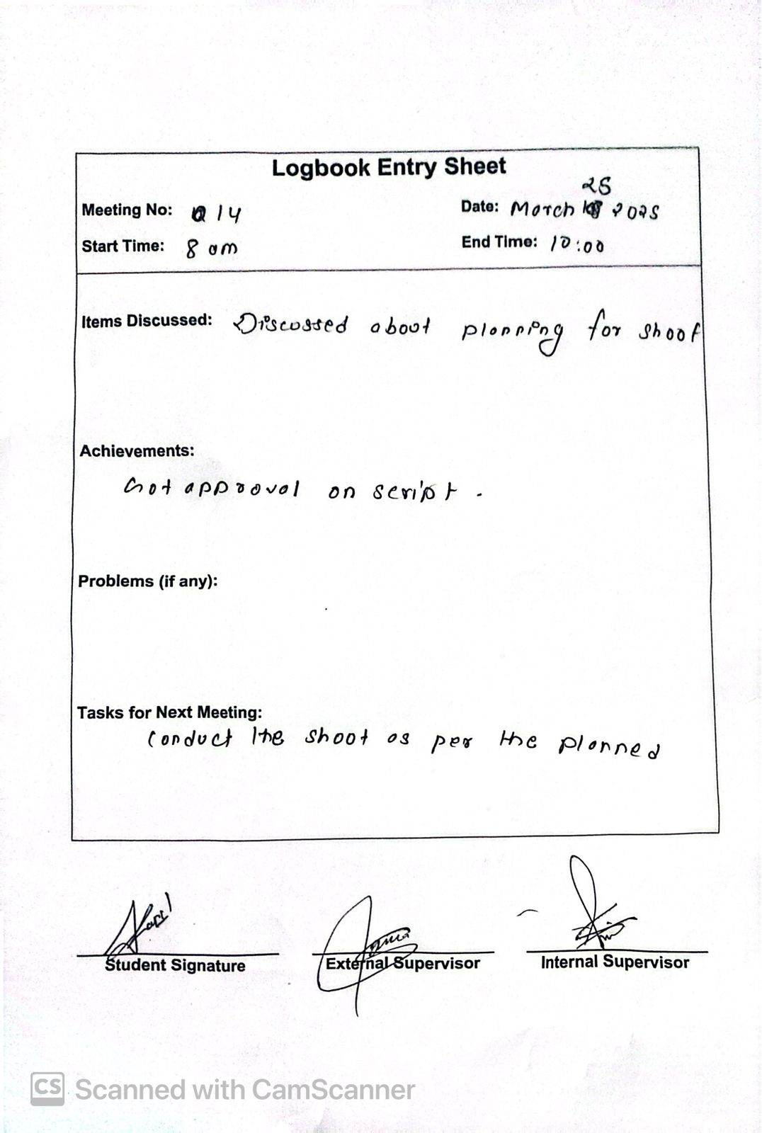

Figure Image of log sheet 13

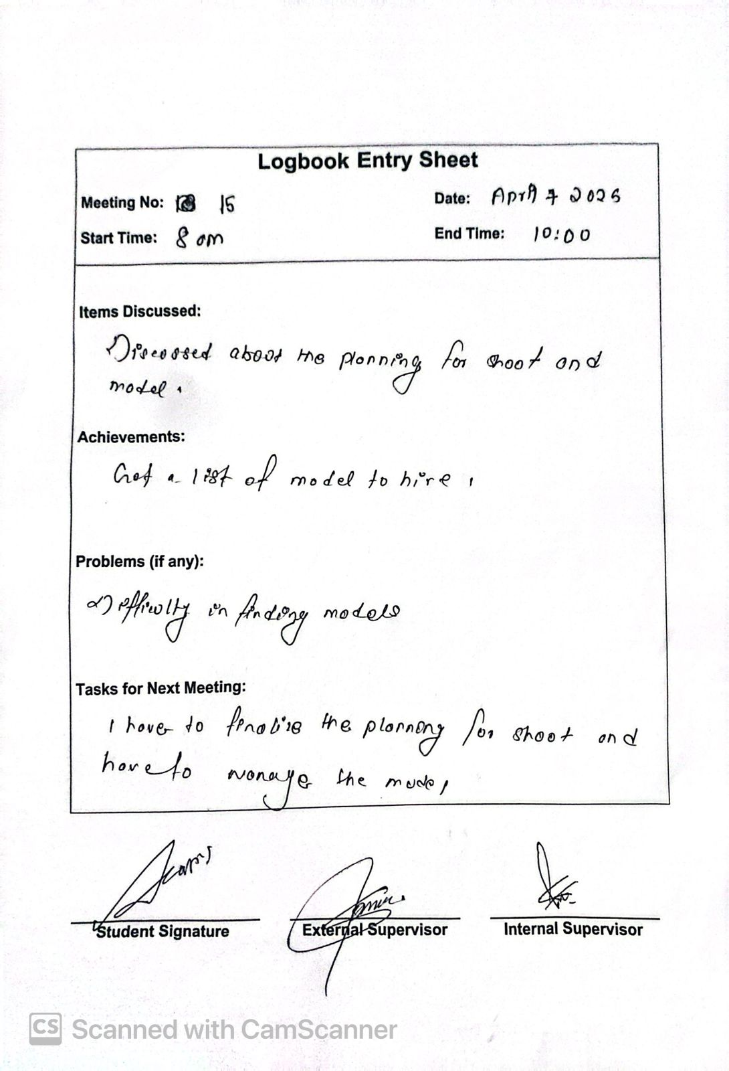

Figure Image of log sheet 14

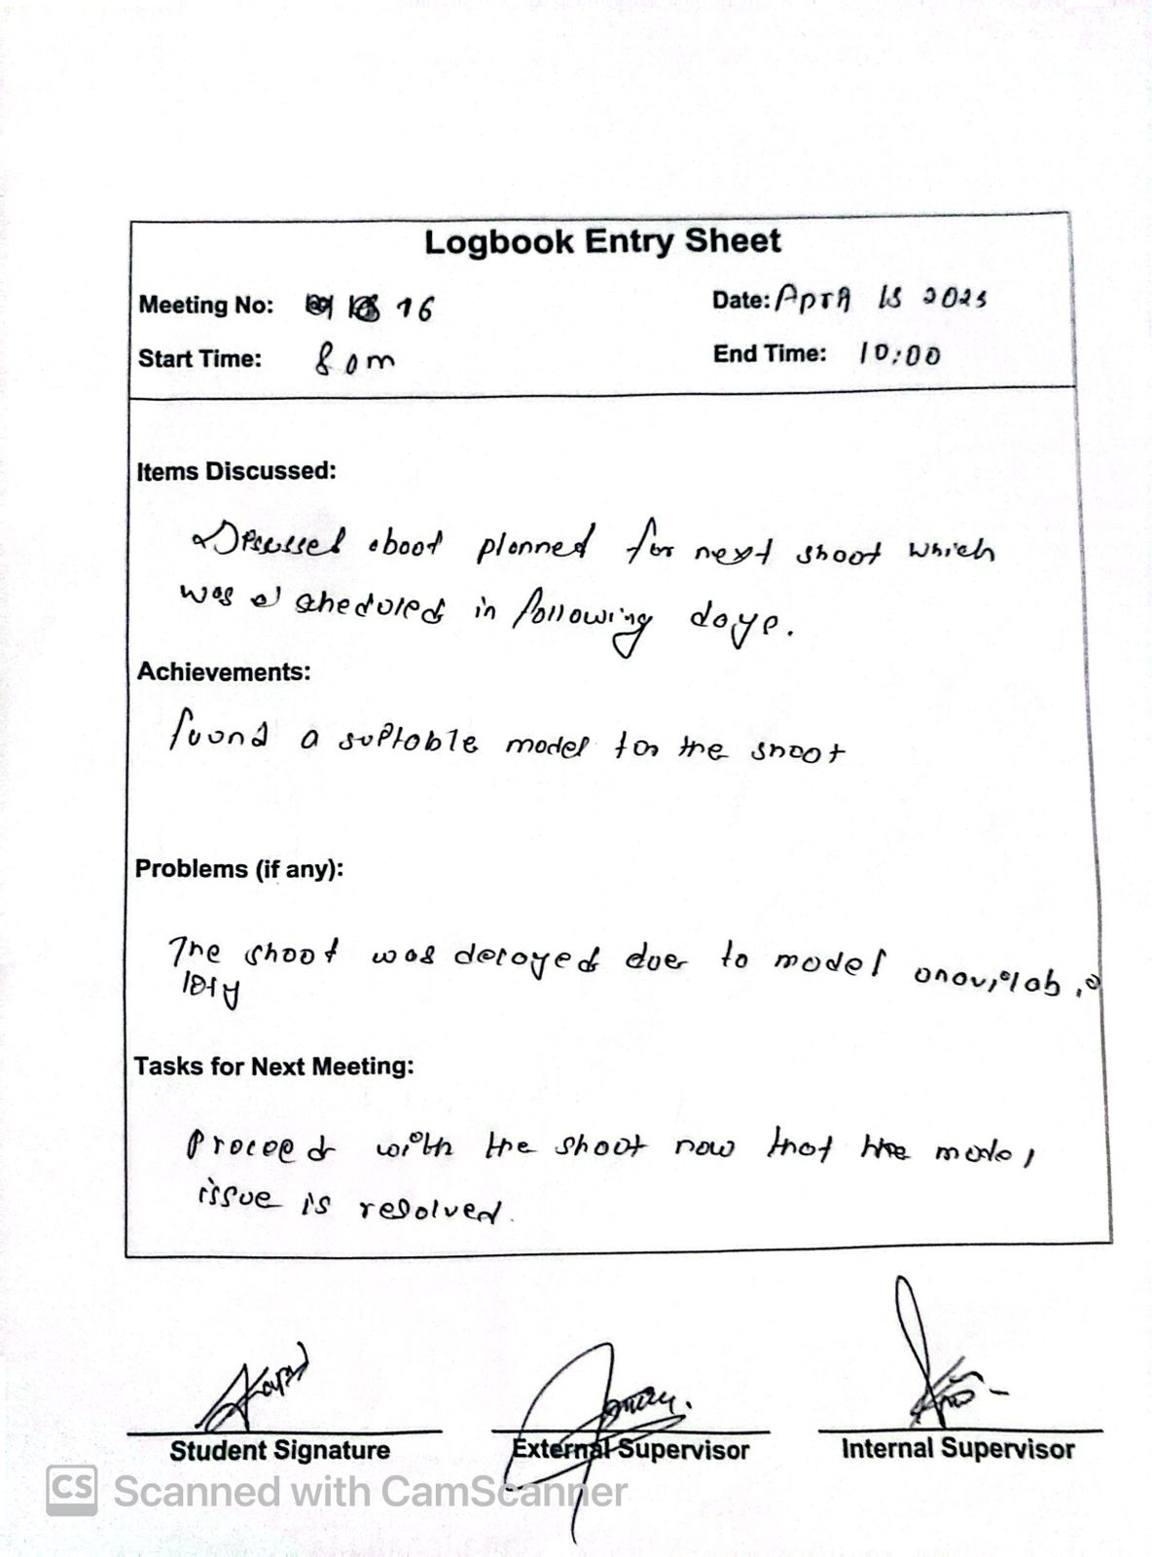

Figure Image of log sheet 15

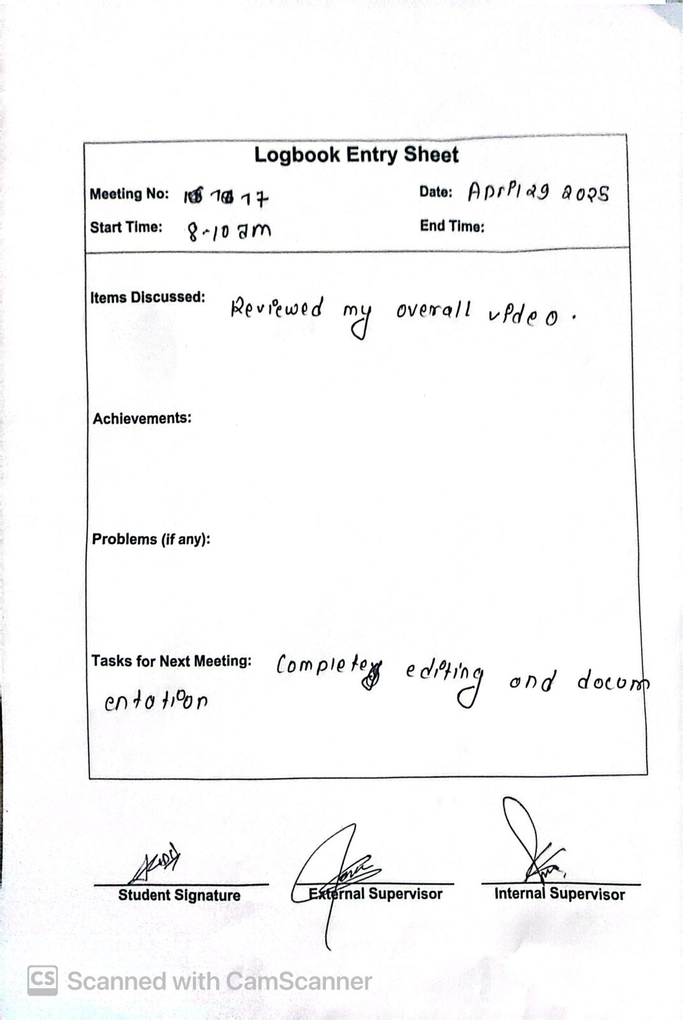

Figure Image of log sheet 16

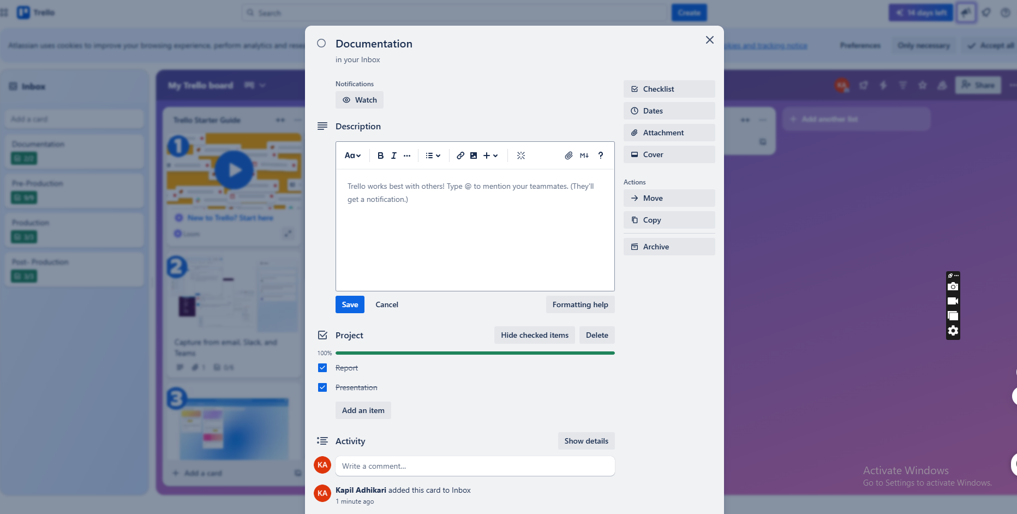

Figure Managing Project in Trello 1

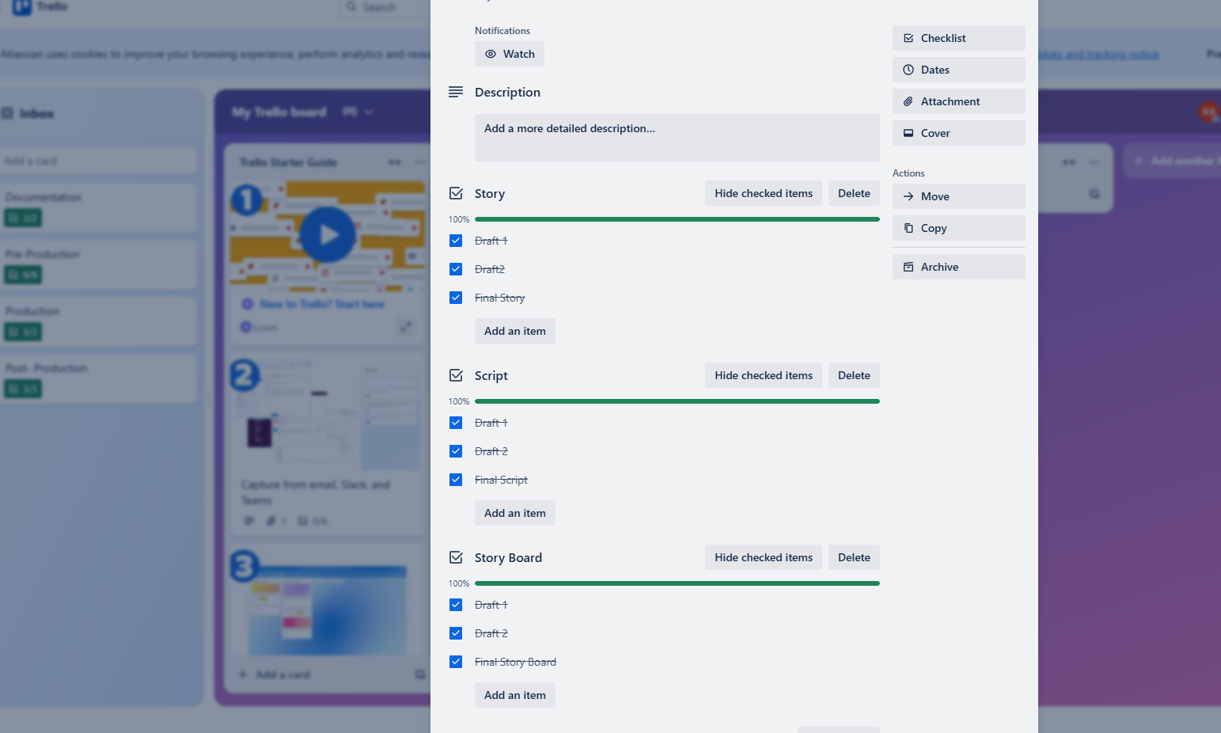

Figure Managing Project in Trello 2

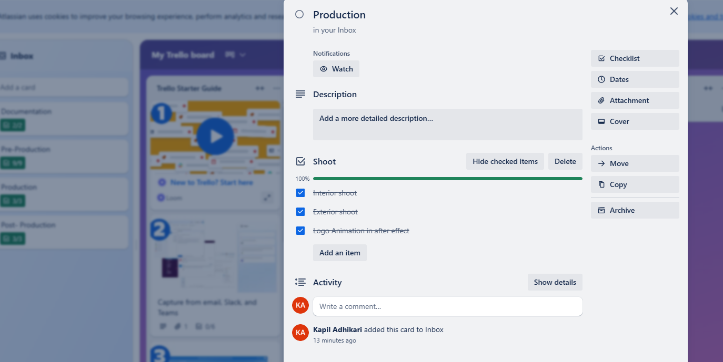

Figure Managing Project in Trello 3

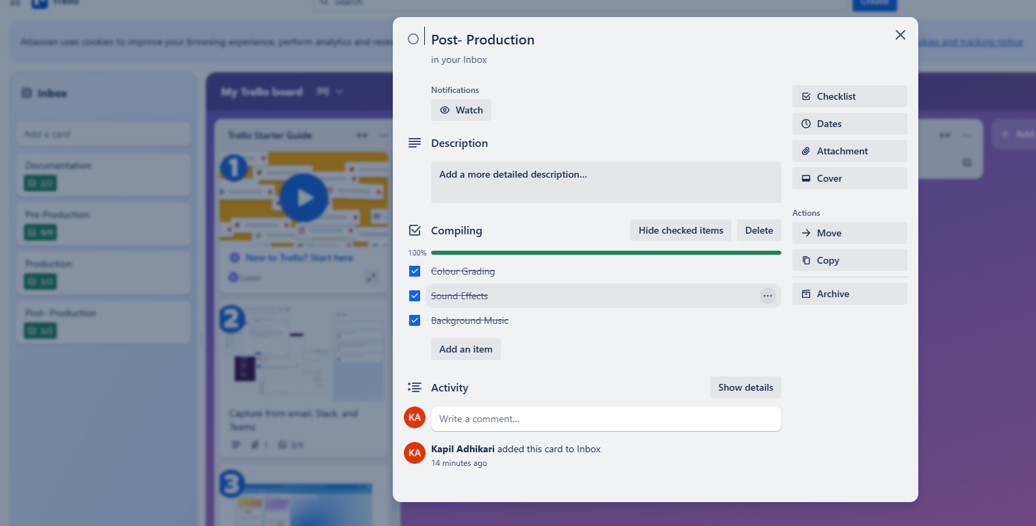

Figure Managing Project in Trello 4